Name

Mathematics Stage 5 Core
Elevation, Depression,
Bearings

Book 1 |  | Version: 261002  Feedback:  https://MrDingMaths.com
Contents
Syllabus Content 2
Learning Intention 3

Syllabus Content
MA5-TRG-C-02 applies trigonometry to solve problems, including bearings and angles of elevation and depression
Solve right-angled triangle problems involving angles of elevation and depression
- Identify and describe angles of elevation and depression
- Solve practical problems involving angles of elevation and depression
Solve right-angled triangle problems involving bearings
- Identify and interpret true bearings and compass bearings
- Explain the difference between true bearings and compass bearings and convert between them
- Solve practical problems involving bearings

Angles of Elevation and Depression

- Angles of Elevation and Depression
- Line of sight is a straight line from your eye to an object.
- Angle of elevation: The angle you turn to look up from the horizontal.
- Angle of depression: The angle you turn to look down from the horizontal.
- The horizontal is a line parallel to the ground.
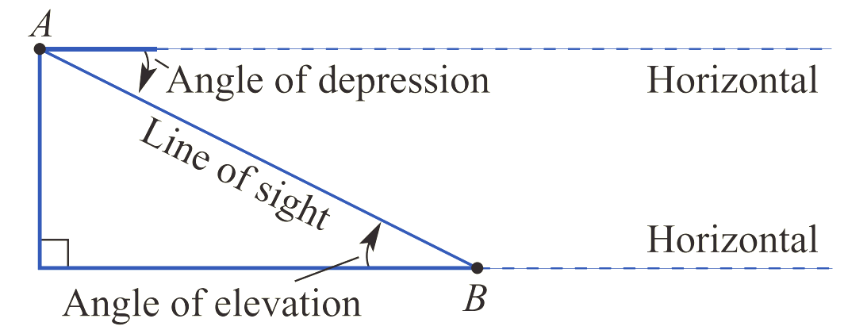

- Identify angles of elevation and depression
Identify whether the angle shown is an angle of elevation, depression, or neither.
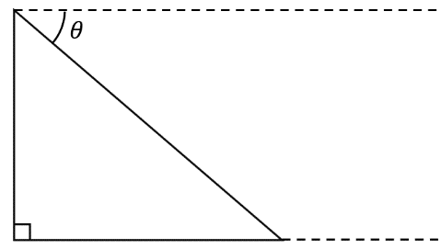
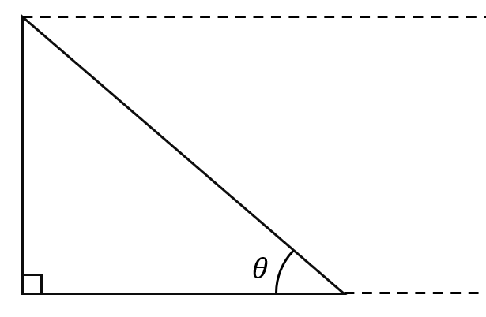
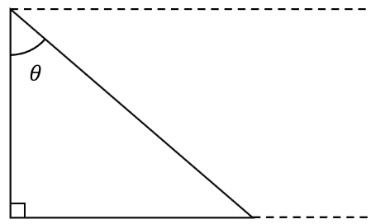
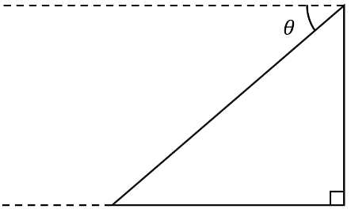 | 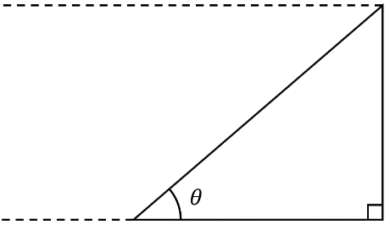 | 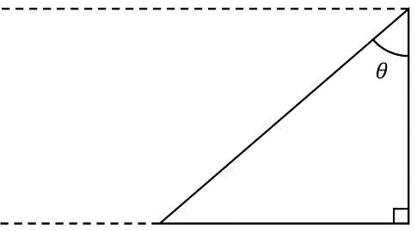
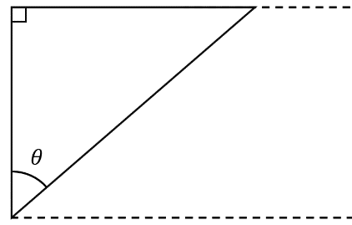 |  | 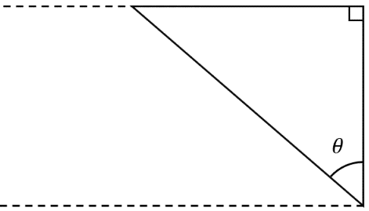  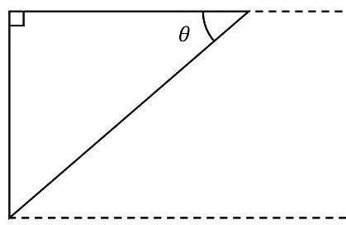

- Finding Angles of Elevation and Depression
- To find angles, we can use these angle relationships:
  - Angles in a right-angle sum to $90°$
  - Angle sum of a triangle is $180°$
  - Alternate angles on parallel lines are equal.

- Example Calculate angles of elevation and depression
Calculate the angle of elevation.  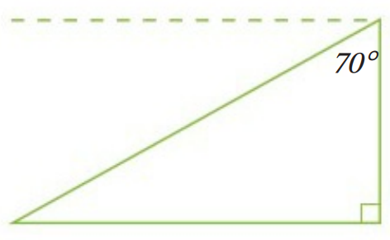  $$θ$$  $$θ+70°+90°=180° (angle sum of a triangle) \\ θ+160°=180° \\ θ=20°$$ | Calculate the angle of depression.  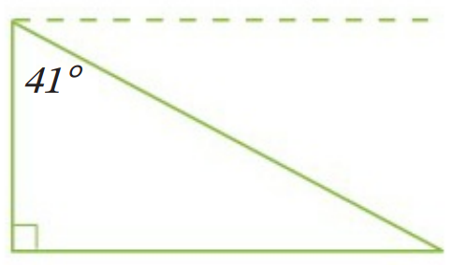  $$θ$$  $$θ+41°=90° (angles in a right angle) \\ θ=90°-41° \\ θ=49°$$

- Guided Practice
- Calculate the angle of elevation.  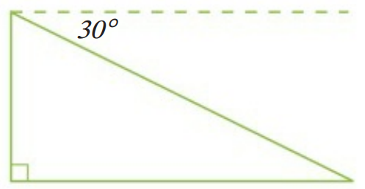  $$30°$$ | 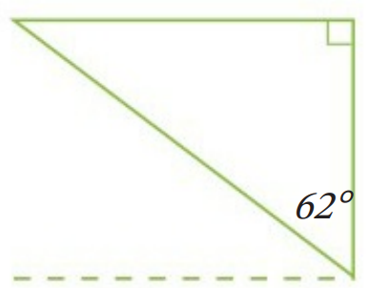  - Calculate the angle of depression.  $$28°$$
- Calculate the angle of elevation.  $$54°$$ | 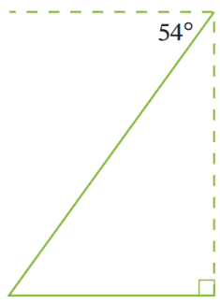  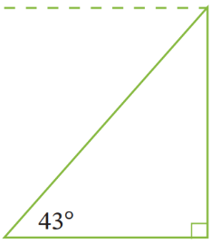  - Calculate the angle of depression.  $$43°$$

- Key Ideas
- The angle of elevation and depression are measured from the ……………………
- The angle of elevation and depression are always equal because they are ……………… angles on parallel lines.

Foundation
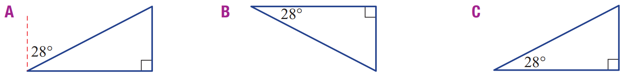
- A girl views a kite at an angle of elevation of $28°$. Which diagram shows this?

C
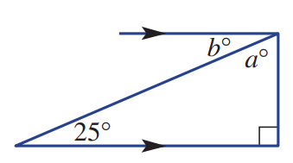
- Find the values of the pronumerals in the diagram:
  - ……………
65$°$
  - ……………
$$25°$$
- Consider the diagram.
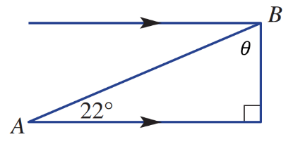
  - Explain why $θ$ is not the angle of depression.

$θ$ is not between the line of sight and the horizontal.
  - Determine the size of the angle of depression from B to A.

$$22°$$
- Mark the angle of elevation θ and find its size.
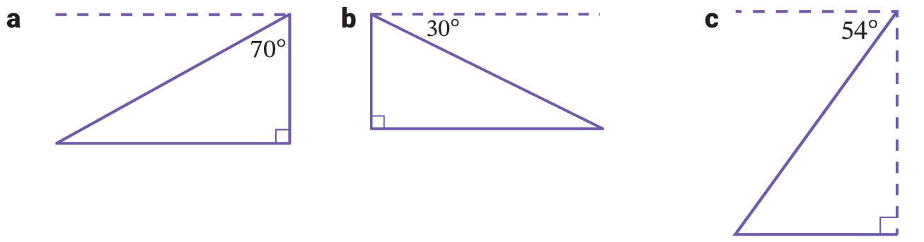  $θ=20°$ | $θ=30°$ | $θ=54°$

- Mark the angle of depression θ and find its size.
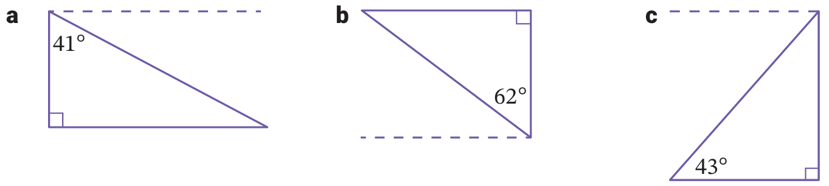  $θ=49°$ | $θ=28°$ | $θ=43°$

Trigonometry with Angles of Elevation and Depression

- Example Solve problems involving angles of elevation and depression
Worked Example | Your Turn
A kite is flying at a height of 45 m above the ground at the end of a string of length 70 m. Find the angle of elevation from the ground to the string.  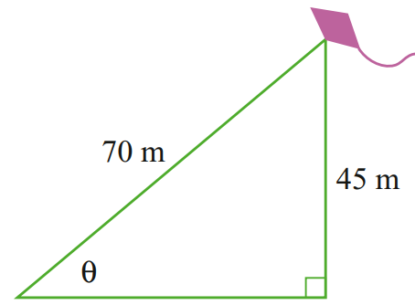  $$\sin{θ}=\frac{45}{70}$$  $θ=\sin^{-1}\left(\frac{45}{70}\right)$  $θ≈40°$ | A kite is flying at a height of 35 m above the ground at the end of a string of length 60 m. Find the angle of elevation from the ground to the string, answer to the nearest minute.  $$35°41'$$
The angle of elevation of the top of a flagpole from the ground, as observed from a point 15 m from its base, is 63°.  Find the height of the flagpole.  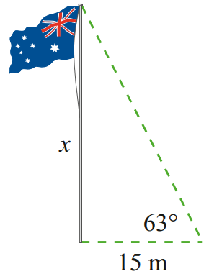  $\tan{(63°)}=$ $\frac{x}{15}$  $15\tan{(63°)}=x$  $x≈29.4 m$ | The angle of elevation of the top of a flagpole from the ground, as observed 50 m from its base, is 38°.  Find the height of the flagpole to 1 d.p.  $39.1$ m
The angle of depression from the top of a vertical cliff, 150 m above sea level, to a boat below is 50°. Find the distance of the boat from the base of the cliff to the nearest metre.  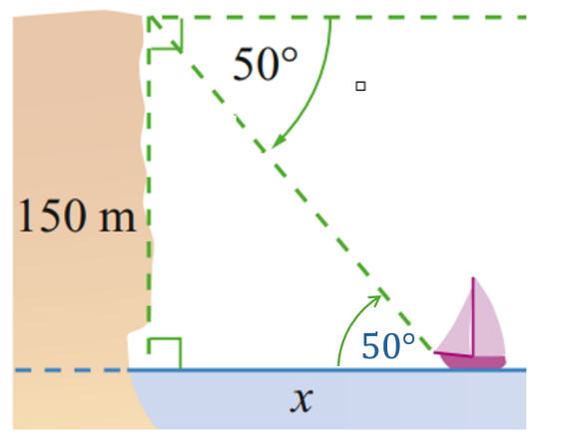  $\tan{(50°)}=$ $\frac{150}{x}$  $x=\frac{150}{\tan\left(50°\right)}$  $x≈126 m$ | The angle of depression from the top of a vertical cliff, 135 m above sea level, to a boat below is 37°. Find the distance of the boat from the base of the cliff to the nearest metre.  179 m

Foundation
- For all of these questions, answer to the nearest whole number.
- A ship is 825 m from a 153 m cliff.  Eric is at the top of the cliff looking down. Calculate the angle of depression.  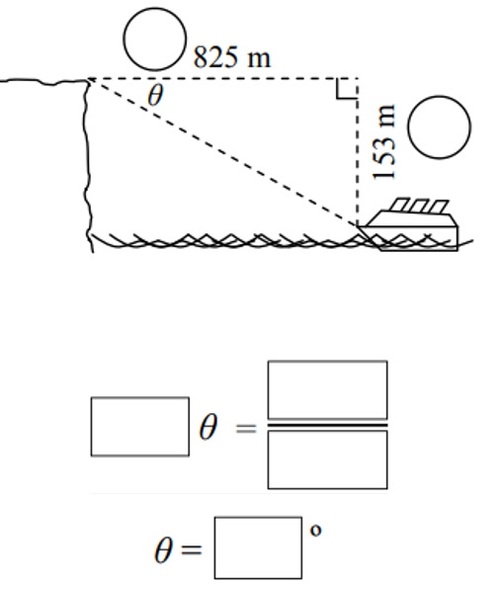  $$11°$$ | 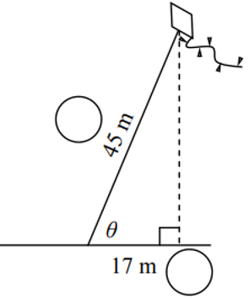  - A flying kite is attached to the ground.  Its string is 45 m long.  The kite is above a point 17 m away. Calculate the angle of elevation.  $$68°$$
- Evie is looking up at a plane that is a ground distance of 3.7 km away and is flying at a height of 800 m.  Calculate the angle of depression.  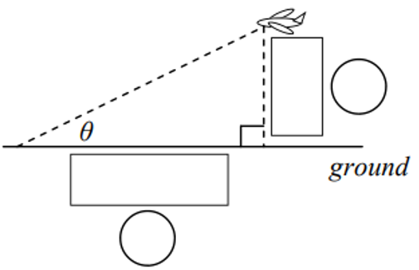  $$12°$$ | 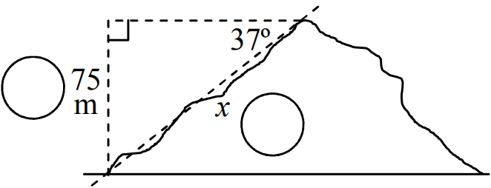  - Jill is on top of a 75 m hill.  The angle of depression from the top to the base of the hill is 37º.  Estimate the distance Jill travelled to climb the hill.  $125$ m
- Ted is looking up at a hot air balloon.  The angle of elevation is 76º and the balloon is above a point 460 m away. Calculate the altitude of the balloon.  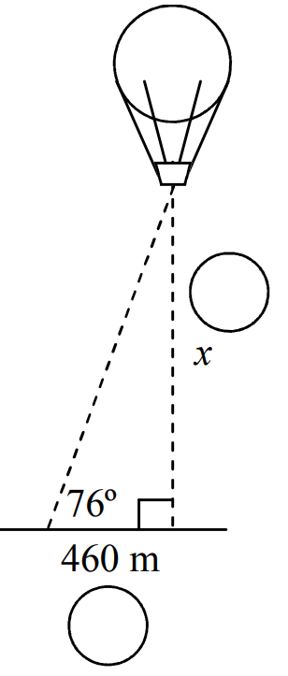  $1845$ m | 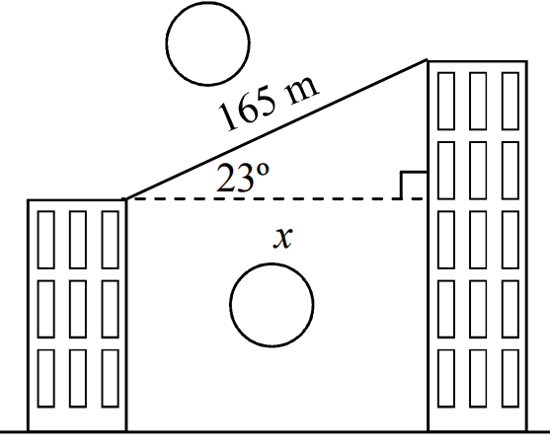  - Bec is set to walk a 165 m long tight-rope suspended between two buildings.  The angle of elevation from the lower building is 23º.  Find the distance between the two buildings.  $152$ m

Development
- The angle of depression of a boat at sea from the top of a vertical cliff 36 m high is 10°. Calculate the distance of the boat from the base of the cliff to the nearest metre.
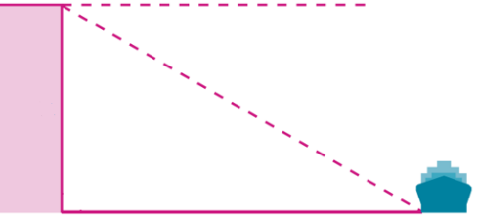

204 m
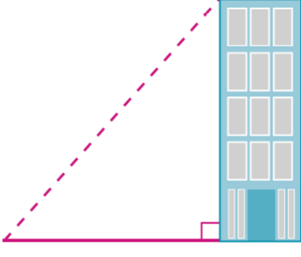
- The angle of elevation of the top of a building from a point 30 m from its base is 55°.
Calculate the height of the building to 1 d.p.

42.8 m
- When Sarah looked from the top of a cliff 50 m high, she noticed a boat at an angle of depression of 25°. How far was the boat from the base of the cliff?
Answer to two decimal places.
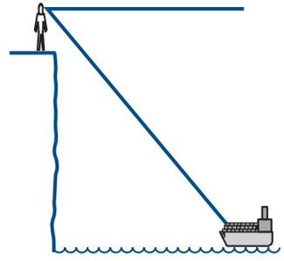

107.23 metres
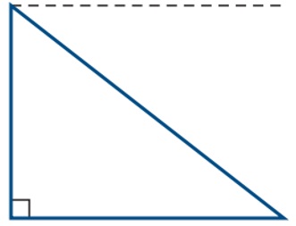
- An iron ore seam slopes down 120 m at an angle of depression from the horizontal of 38°.
The mine engineer wishes to sink a vertical shaft.
What is the depth of the required vertical shaft? Answer to the nearest metre.

74 m
- A tourist viewing Sydney Harbour from a building 130 m above sea level observes a ferry 800 m from the base of the building. Find the angle of depression. Answer to the nearest degree.
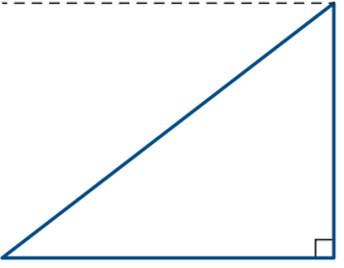

$$9°$$
- The angle of elevation of the top of a castle wall from a point on the ground 25 m from the base of the castle wall is 32°. Find the height of the castle wall to the nearest metre.

16 m
- From a point on the ground, Emma measures the angle of elevation of an 80 m tower to be 27°. Find how far Emma is from the base of the tower, correct to the nearest metre.

157 m
- From a ship, a person is spotted floating in the sea at a horizontal distance of 200 m from the ship. If the viewing position on the ship is 20 m above sea level, find the angle of depression from the ship to person in the sea. Give your answer to the nearest degree.

6°
- A power line is stretched from a pole to the top of a house. The house is 4.1 m high and the power pole is 6.2 m tall. The horizontal distance between the house and the power pole is 12 m. Find the angle of elevation of the top of the power pole from the top of the house to the nearest degree.
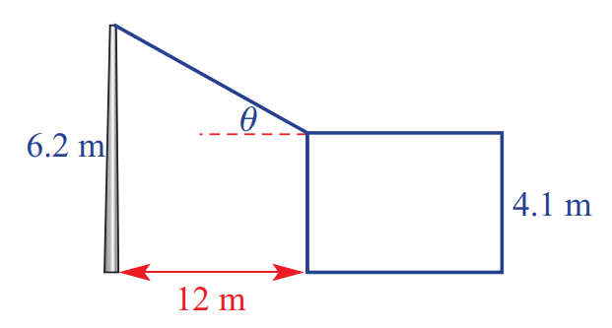

10°
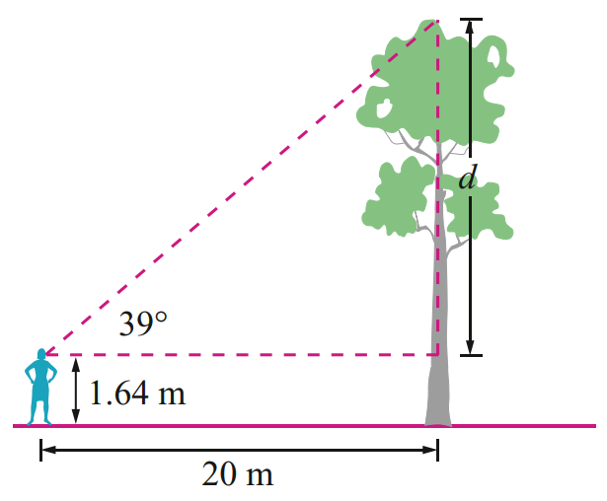
- From a point 20 m from the base of a tree, Sophia measures the angle of elevation of the top of the tree to be 39°. Her eye level is 1.64 m above the ground.
Calculate the height of the tree in metres correct to two decimal places.

17.8 m
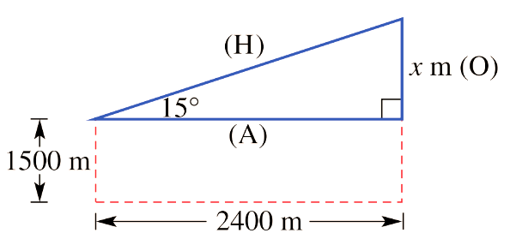
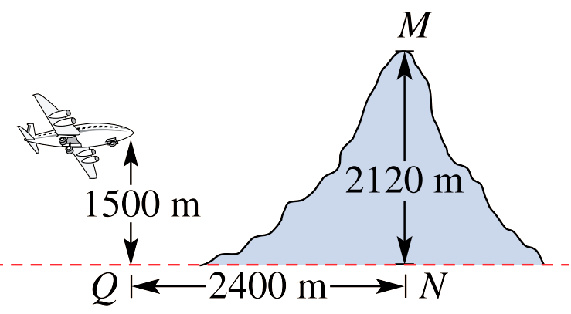
- An aeroplane flying at an altitude of 1500 m starts to climb at an angle of 15° to the horizontal when the pilot sees a mountain peak 2120 m high, 2400 m away from him horizontally.

  - Calculate the value of $x$. What does this represent?

$643.078…$
This represents how much the plane climbs if it travelled 2400 m at an angle of elevation of 15$°$
  - Will the aeroplane clear the mountain?

Yes, since the plane needs to climb $2120-1500=620$ m
- A plane flying at 1850 m starts to climb at an angle of 18° to the horizontal when the pilot sees a mountain peak 2450 m high, 2600 m away from him in a horizontal direction.
Will the pilot clear the mountain?
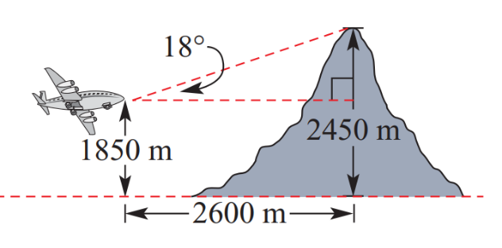

yes by 244.8 m
- A submarine initially at sea level dives at an angle of 11° to the horizontal.
At a horizontal distance of 1200 m there is an uncharted reef at a depth of 240 m.
Will the submarine pass over the reef?

Yes, by 7 m
- A plane has run out of fuel and is gliding at an angle of depression of $10°20'$.
If it is at a height of 800 m and the airport is 4.7 km away, will it be able to reach the airport?

No, the plane can only glide 4387.6 m before crashing.

Mastery
- 2019 HSC Standard 2 Band 5
An owl is 7 metres above ground level, in a tree. The owl sees a mouse on the ground at an angle of depression of 32°.
How far must the owl fly in a straight line to catch the mouse, assuming the mouse does not move? Answer to 1 d.p.

13.2 m
- 2009 HSC Standard 2 Band 5
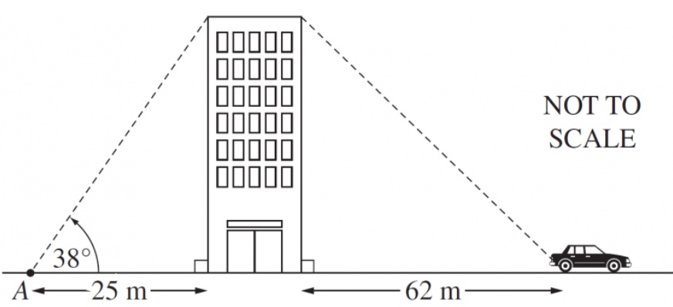
Calculate the angle of depression from the top of the building to the car.
Answer to the nearest minute.

$$17°29'$$
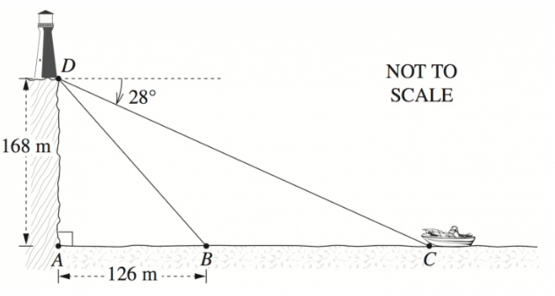
- 2010 HSC Standard 2 Band 5

- Calculate the angle of depression from $D$ to $B$ to the nearest degree.  $$53°$$ | - Find the distance from $C$ to $B$, to the nearest metre.  $190$ m
- From a point P, 200 m from the base of a building, the angles of elevation of the bottom and top of a flagpole on top of the building are 34° and 36° respectively.
Calculate the height, AB, of the flagpole.
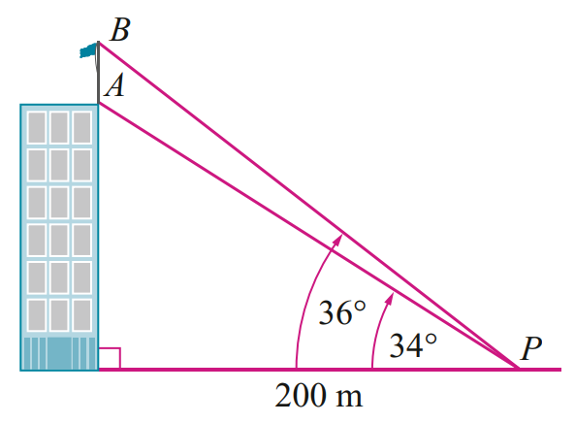

10.4 m
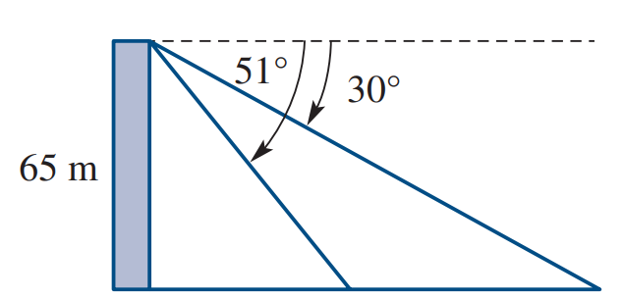
- Jack is on the top of a 65 m high cliff. He observes a man swimming out to sea at an angle of depression of 51°. Jack also sees a boat out to sea at an angle of depression of 30°.
Find, to the nearest metre, the distance between the man and the boat.

60 m
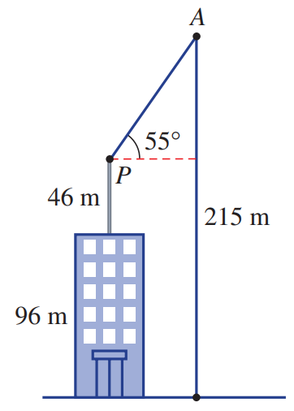
- The pivot point (P) of the main supporting arm (AP) of a construction crane is 46 metres above the top of a 96-metre tall office building. When the supporting arm is at an angle of 55° to the horizontal, the length of cable dropping from the point A to the ground is 215 metres.
Find the length of the main supporting arm (AP), to the nearest centimetre.

89.12 m

True Bearings

- True Bearings
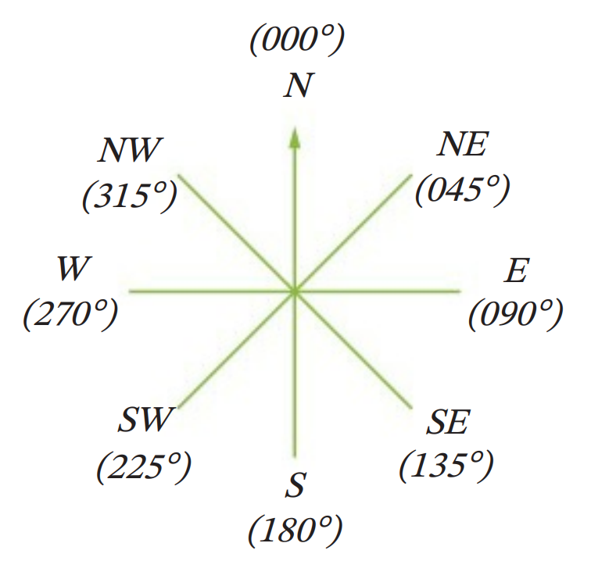
- Bearings: https://www.geogebra.org/m/er3jqacn
- Bearings give a travel direction from one point to another.
- With bearings, we are always taking a top-down view.

- True bearing measures the angle to turn clockwise from north.
- True bearings always use three digits.
If a navigator only hears two digits, then they know they need it to be repeated.

- Example Sketch true bearings
The bearing of A from O is 060$°$ | 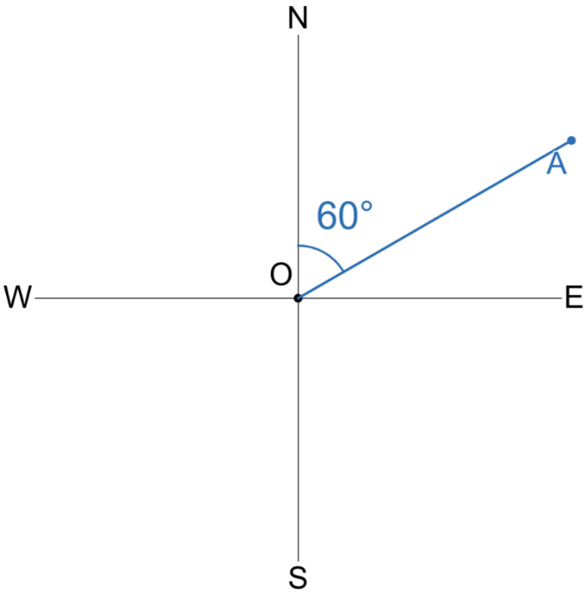  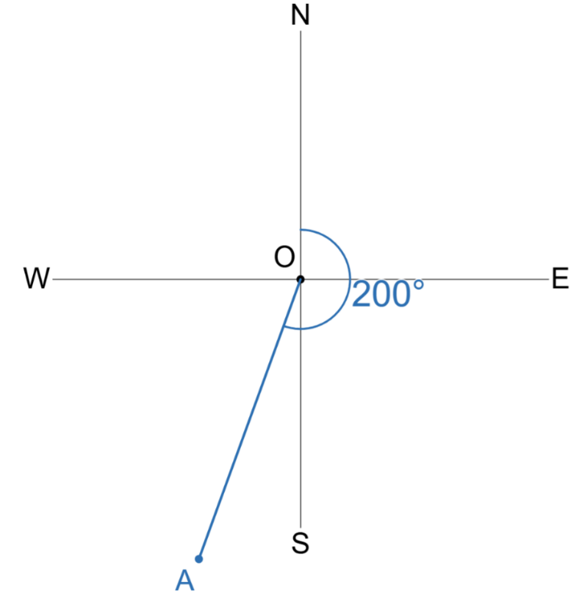  The bearing of A from O is 200$°$

- Guided Practice
Sketch these true bearings of A from O.
- $225°$  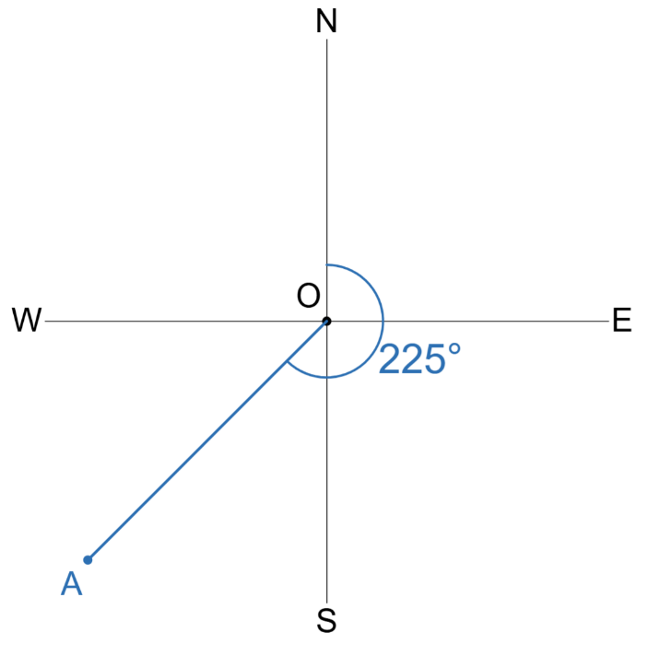  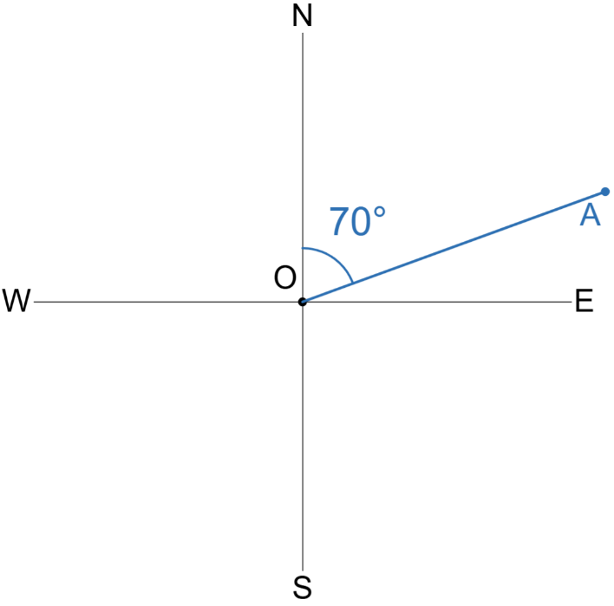  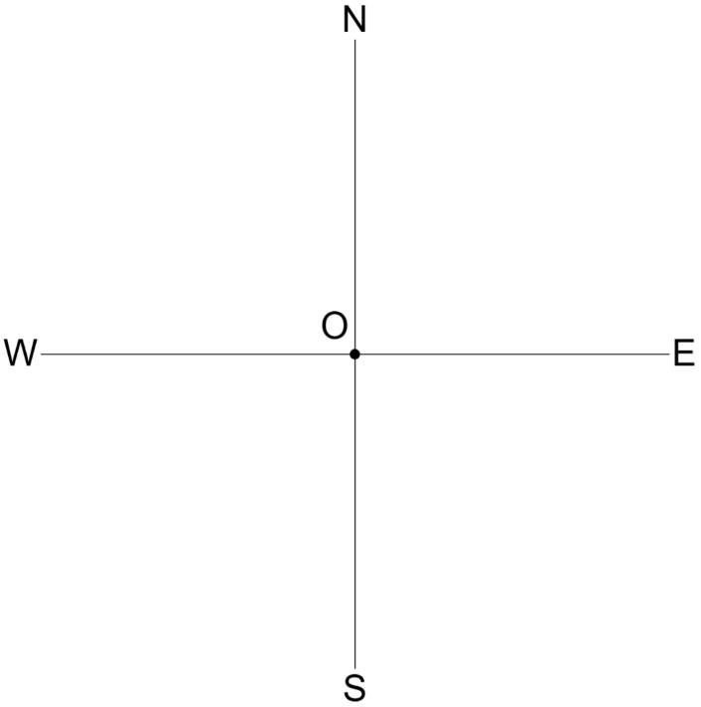 | - $070°$ |  | - $330°$  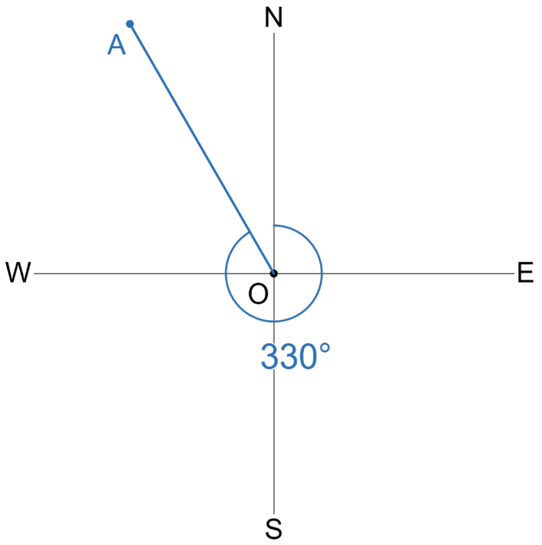
- Example Interpret true bearings
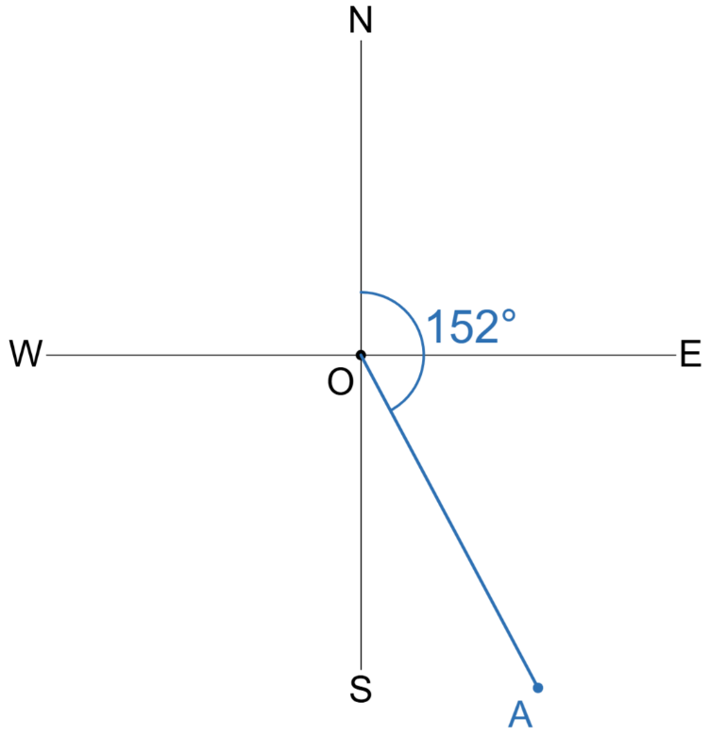  Write the true bearing of A from O  $152°$ |  | 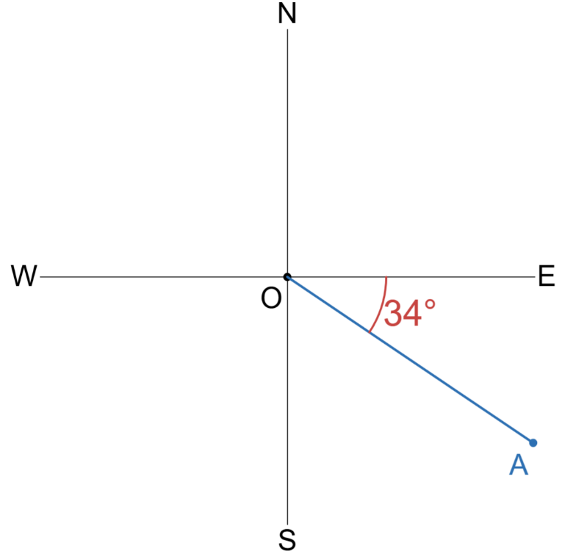  Write the true bearing of A from O  $90°+34°$  $=124°$

- Guided Practice
Write the true bearing of $A$ from $O$
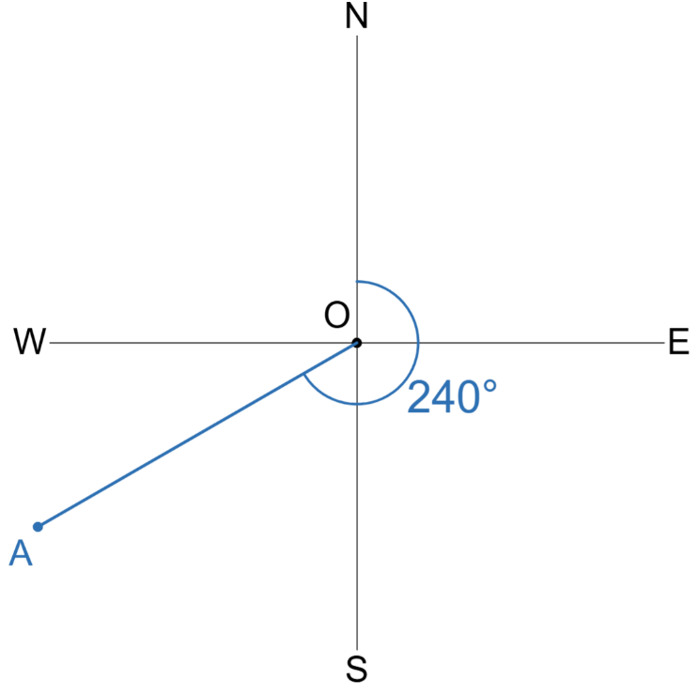  $$240°$$ | 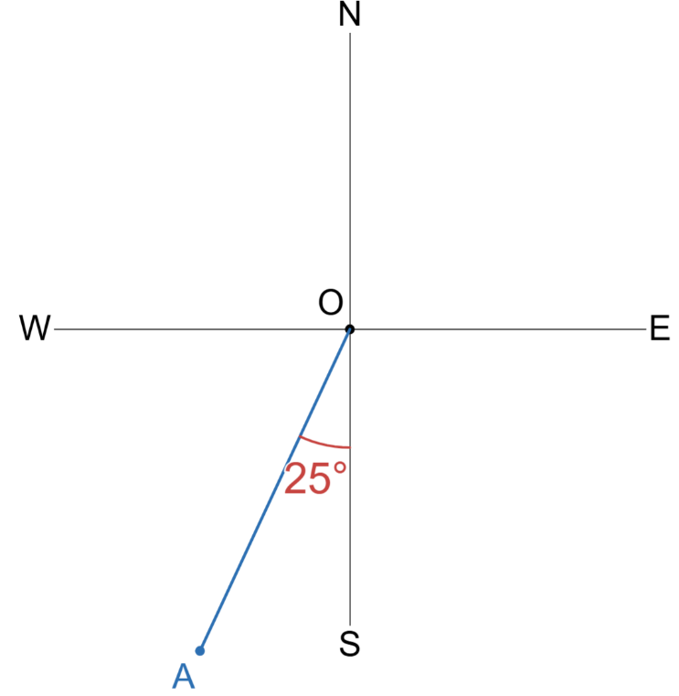  $$205°$$ | 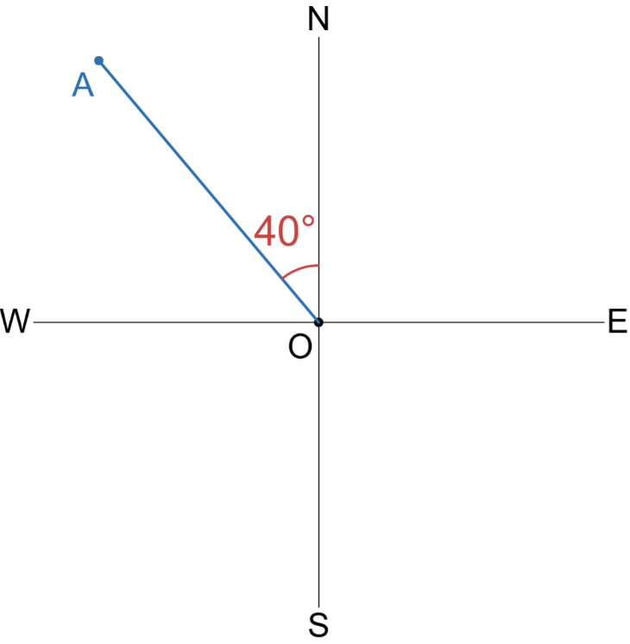  $$320°$$

- Key Ideas
- A bearing indicates a direction. A true bearing states the angle to …………… clockwise, starting from …………………
- A true bearing is always written with …………… digits.

Foundation
- Express the bearing of A from O as a true bearing.
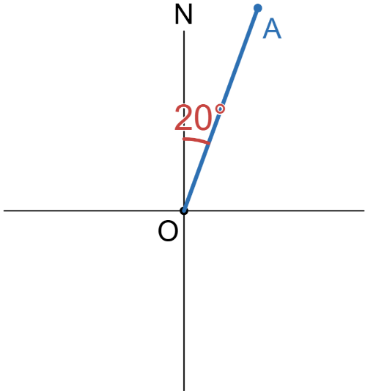  020° | 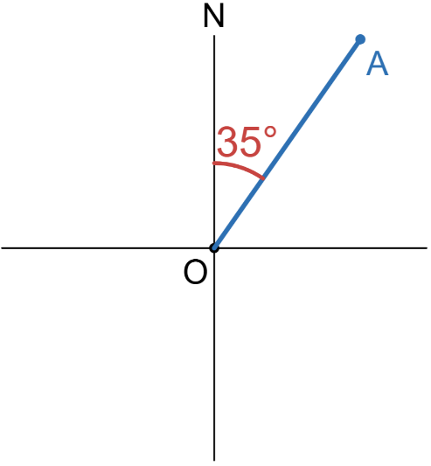  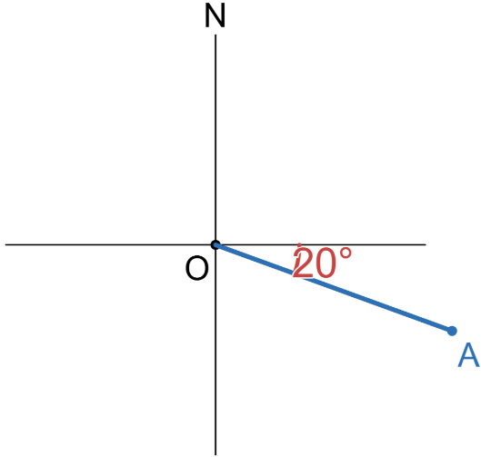  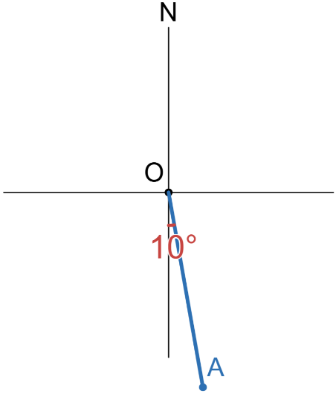  035° | 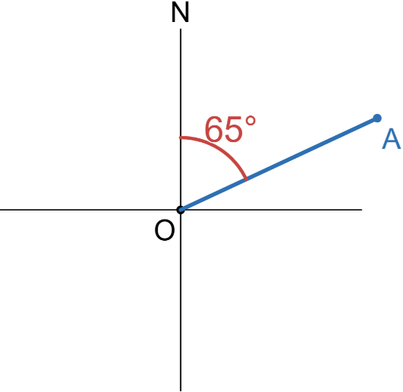  065°
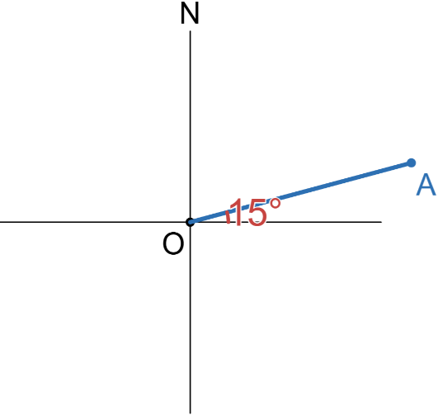  075° | 110° | 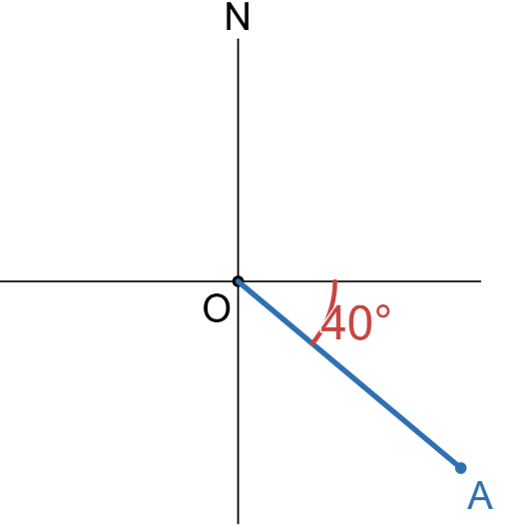  130°
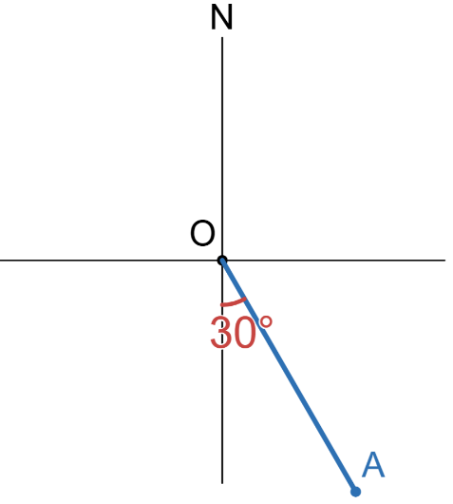  150° | 170° | 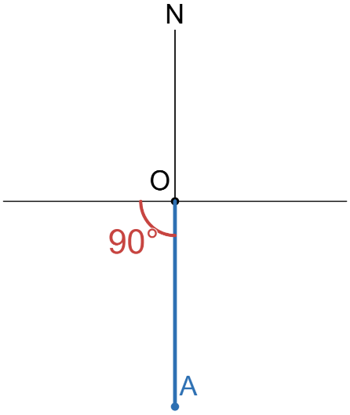  180°
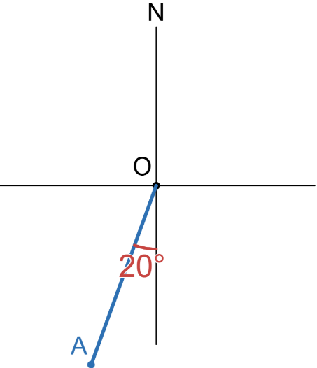  200° | 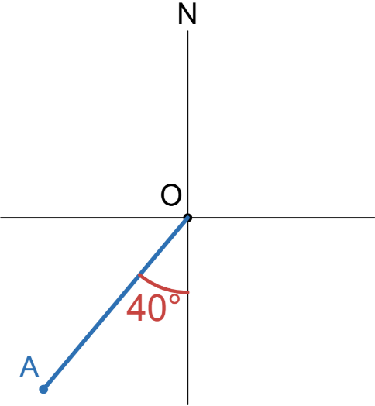  220° | 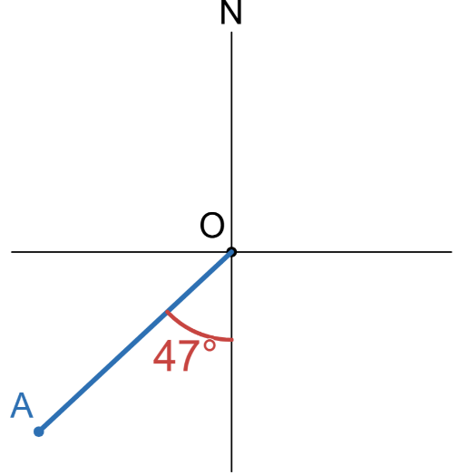  227°
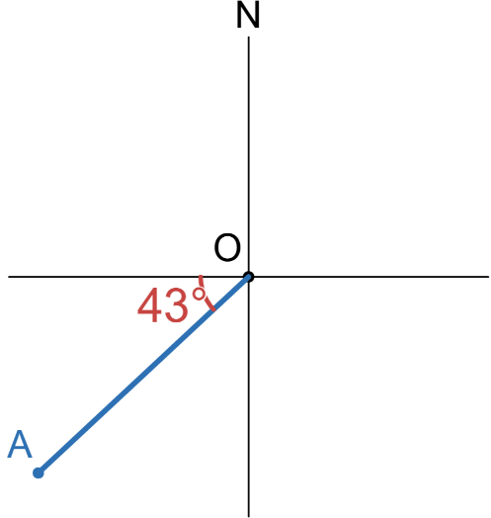  227° | 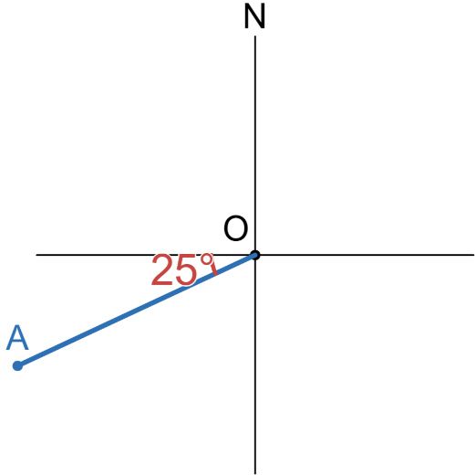  245° | 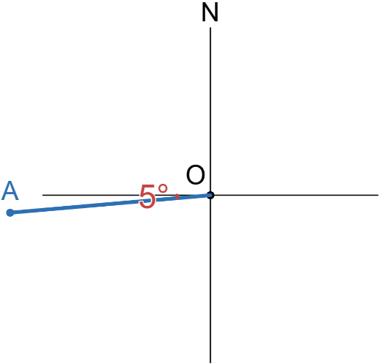  265°
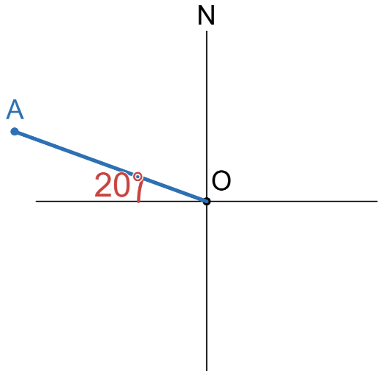  290° | 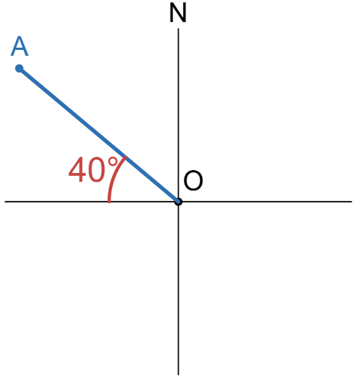  310° | 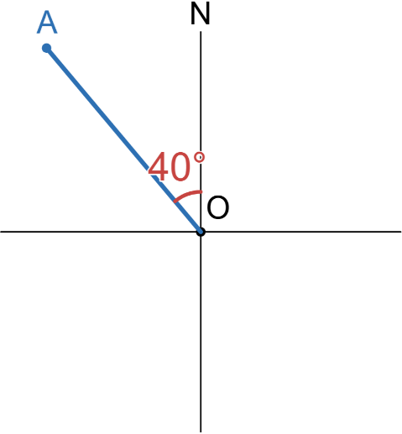  320°

Compass Bearings

- Compass Bearings
Compass bearings tell you an acute angle to turn, starting from North or South.
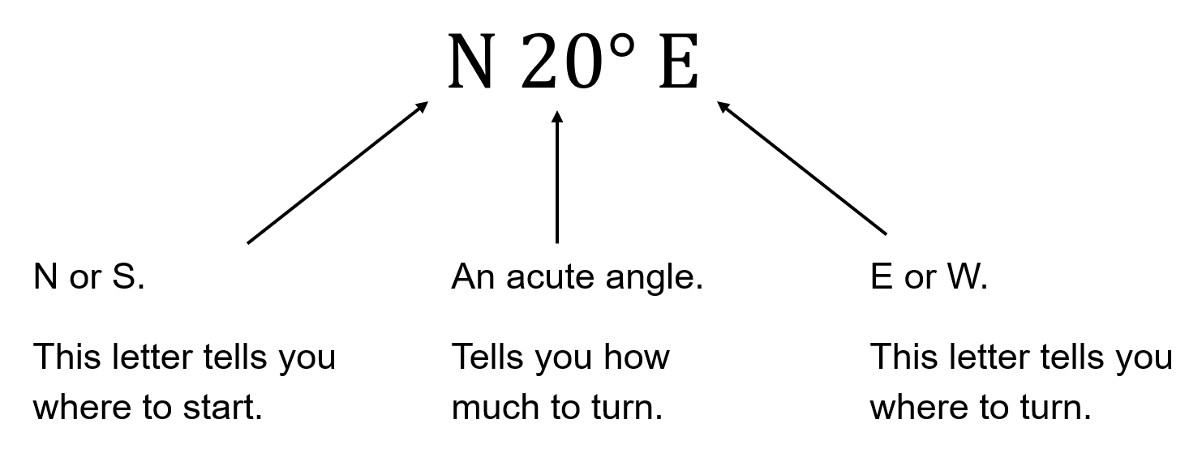

- Example Sketch a compass bearing
The bearing of A from O is $N60°W$ | 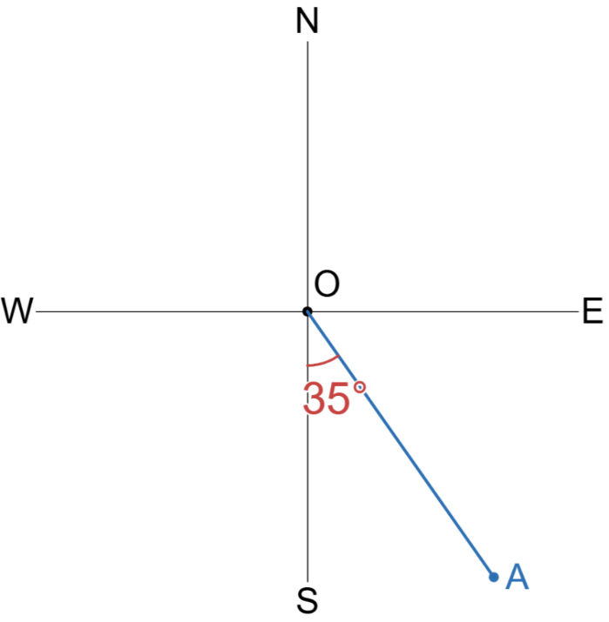  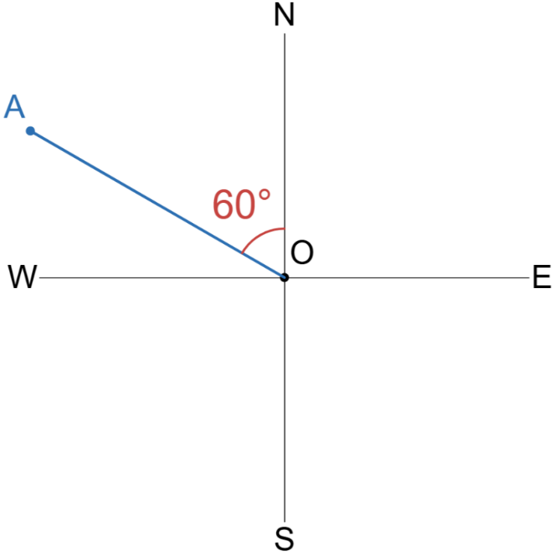  The bearing of A from O is $S35°E$

- Guided Practice
Sketch these compass bearings of A from O.
- $N75°W$  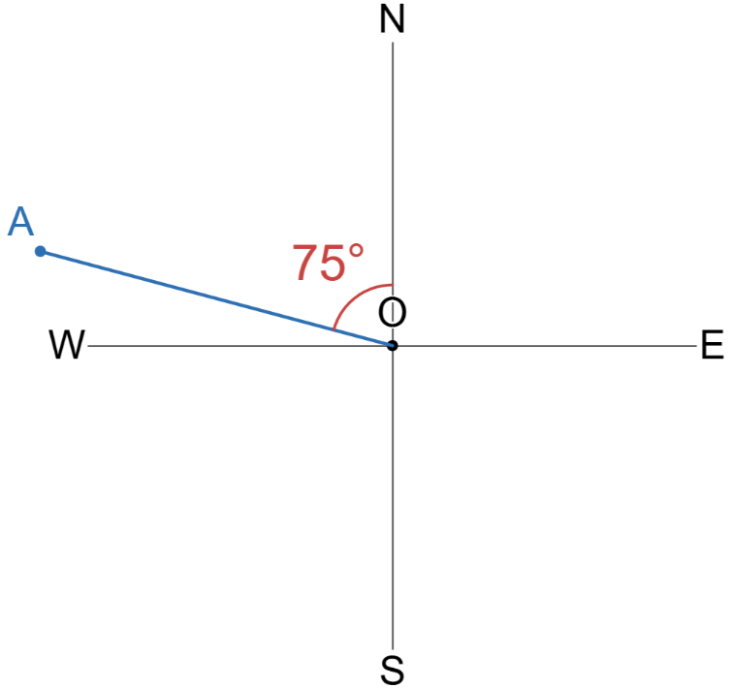  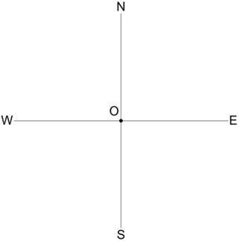 | - $S55°E$  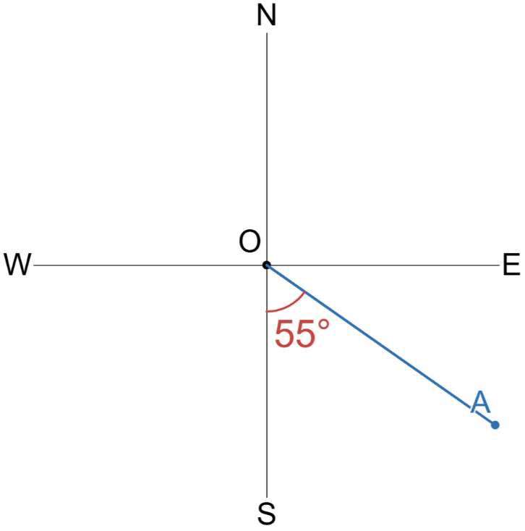 | - $S80°W$  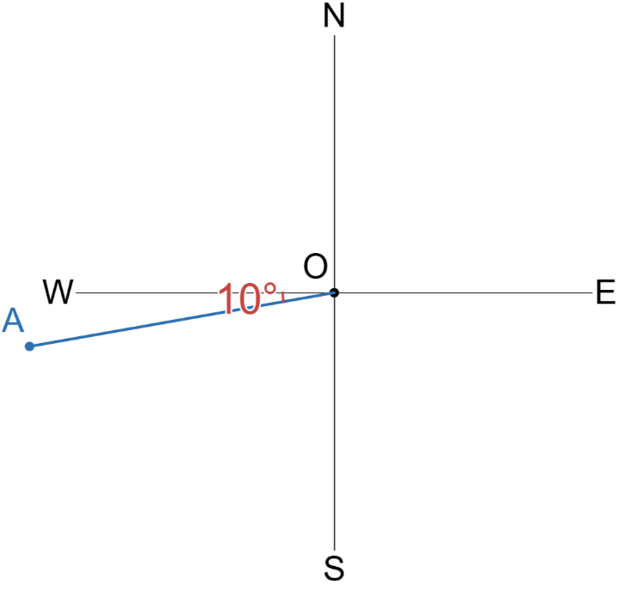

- Key Ideas
- A compass bearing states the ……………… angle to turn ………… or …………, starting from North or South.
- Example Convert from compass to true bearing
$S20°E=180°-20°=160°$  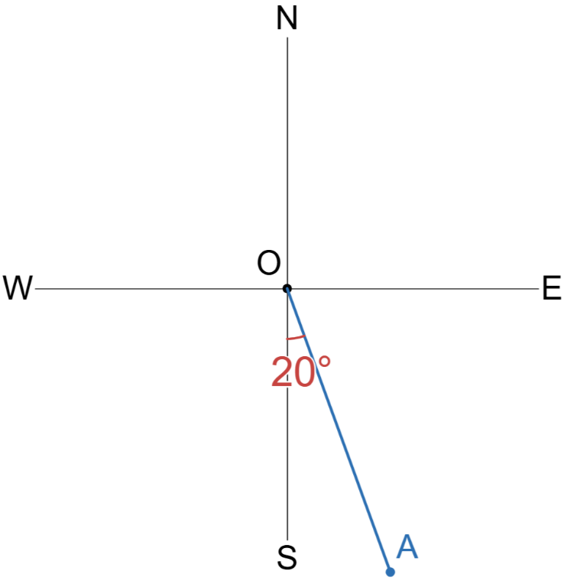 | 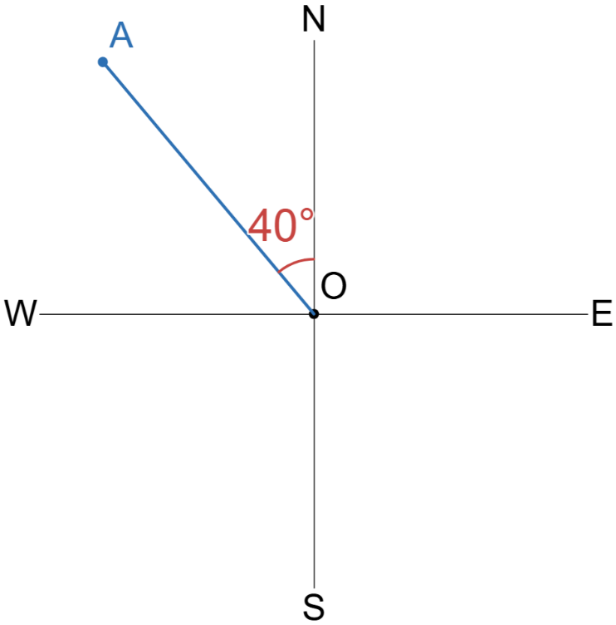  $N40°W=360°-40°=320°$

- Guided Practice
State the compass bearing of A from O and convert to true bearing.
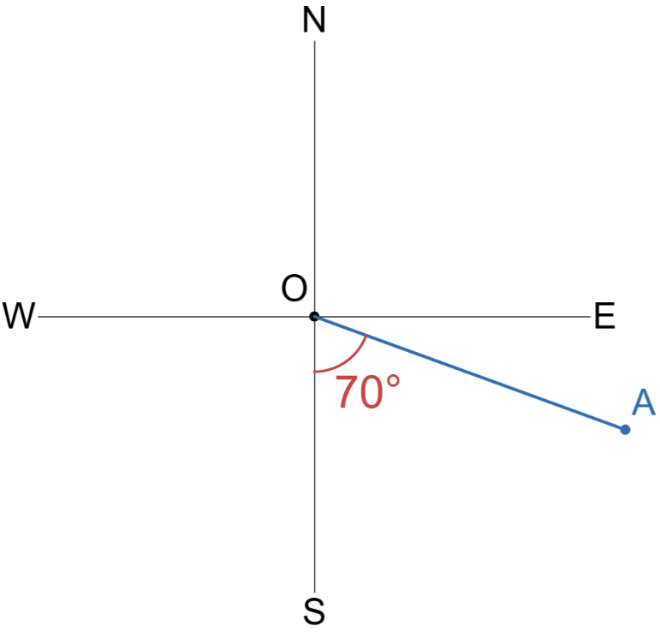  Compass:  S70°E  True:  110° | 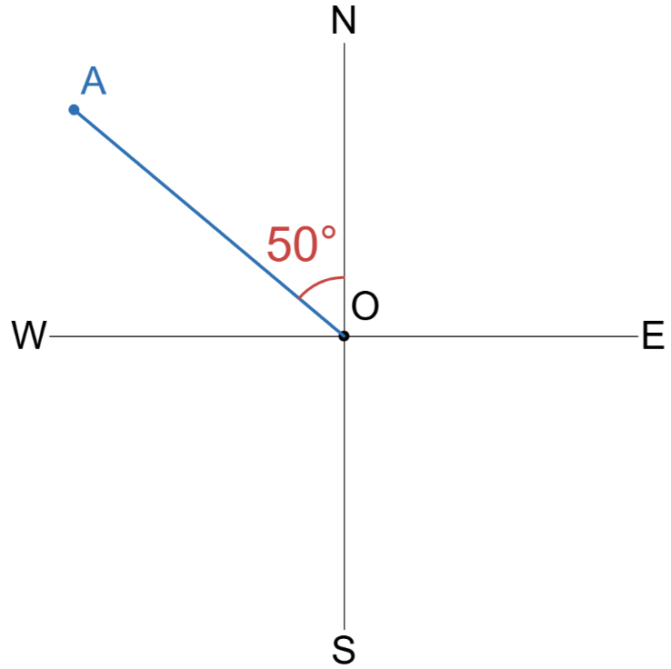  Compass:  N50°W  True:  310° | 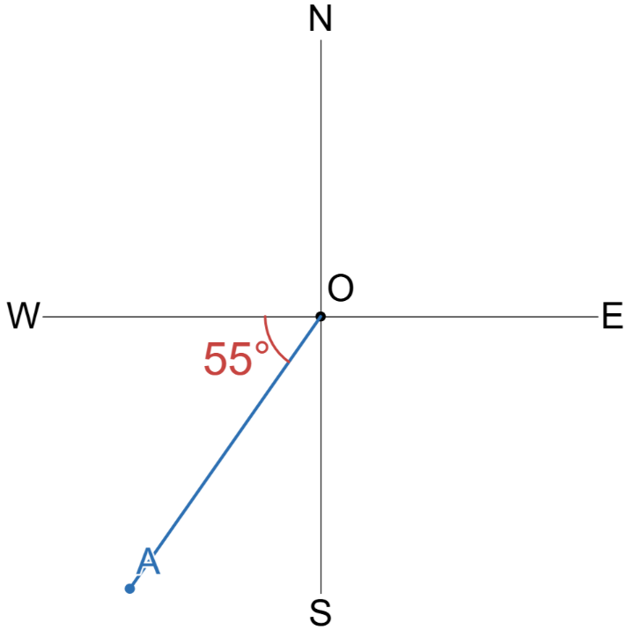  Compass:  S35°W  True:  215°

Foundation
- Express these bearings in both compass and true bearing.
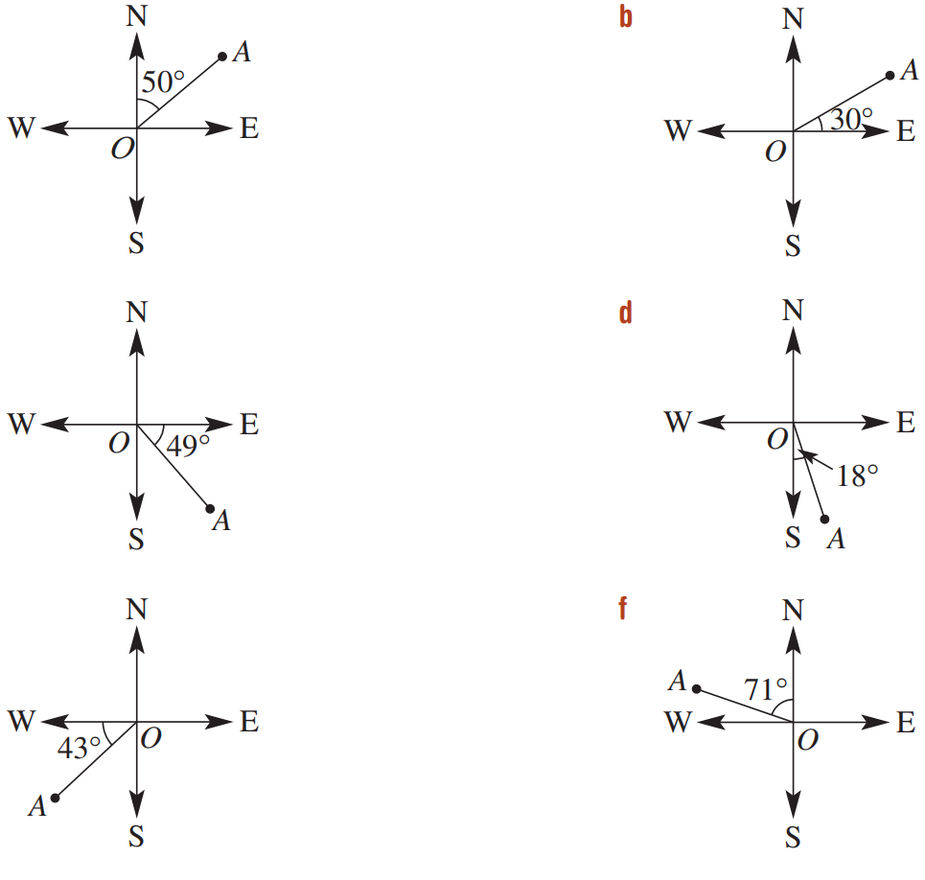  Compass:  N50°E  True:  050° | Compass:  S18°E  True:  162° | Compass:  S41°E  True:  139°
Compass:  N60°E  True:  060° | Compass:  S47°W  True:  227° | Compass:  N71°W  True:  289°

- Explain why $E40°N$ is not a valid compass bearing.
A compass bearing always starts from N or S.

- Explain why $40°$ is not a valid true bearing.
A true bearing is always 3 digits.

- Sketch these bearings.
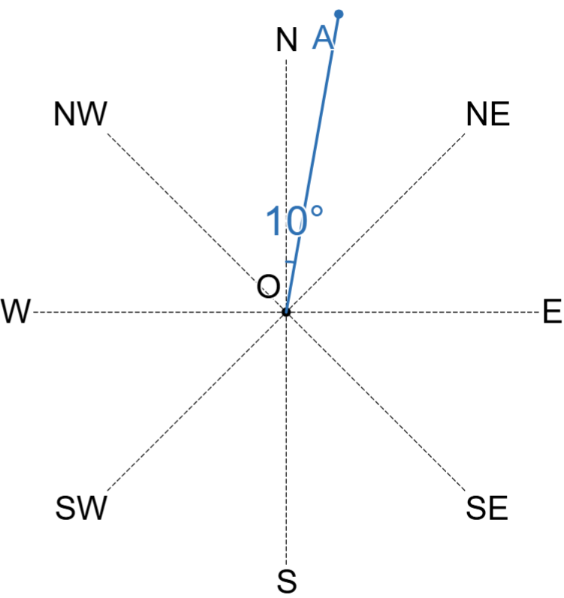  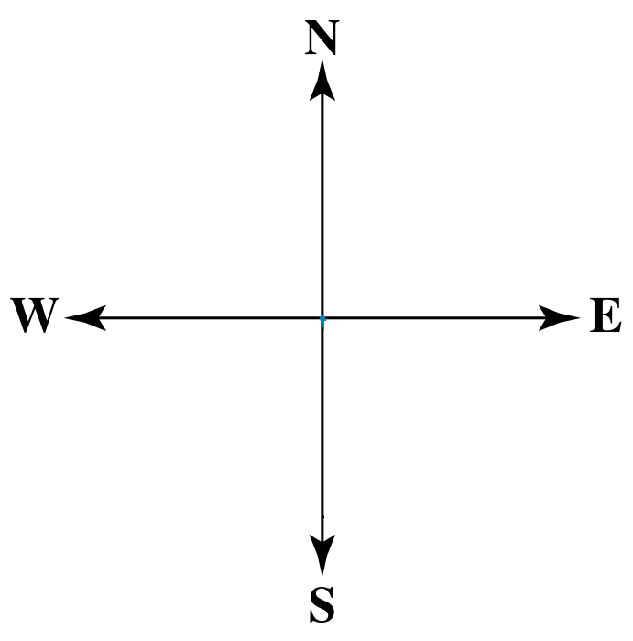  - $N10°E$ | - $S25°W$  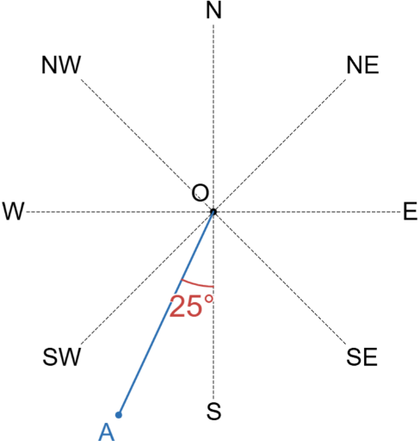 | - $N60°W$  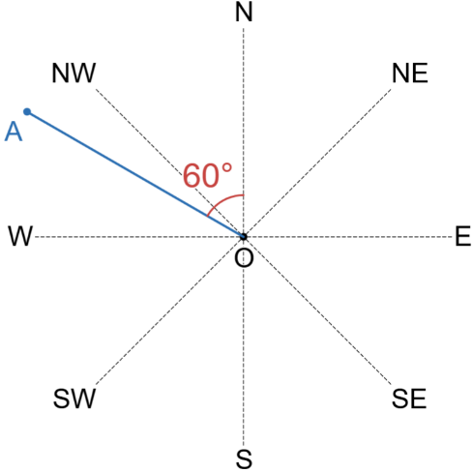
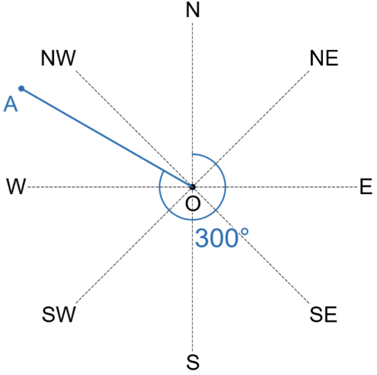  - $300°T$ | - $105°T$  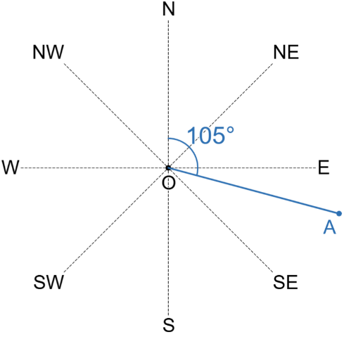 | 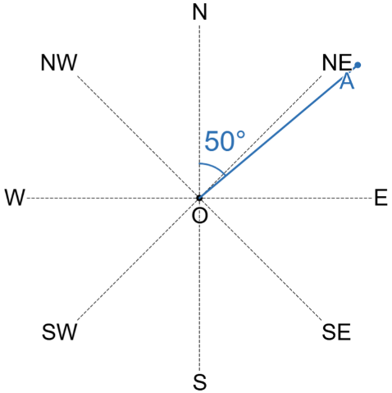  - $050°T$

Development
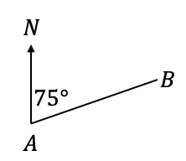
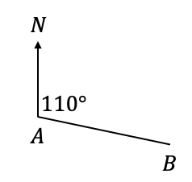
- State the true bearing of:
- $B$ from $A$  $$110°$$ | - $B$ from $A$  $$075°$$ | 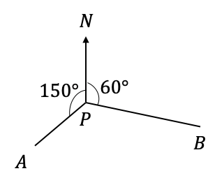  - $A$ from $P$  $$210°$$

- Write the bearing of $A$ from $O$ as compass bearings and true bearings.
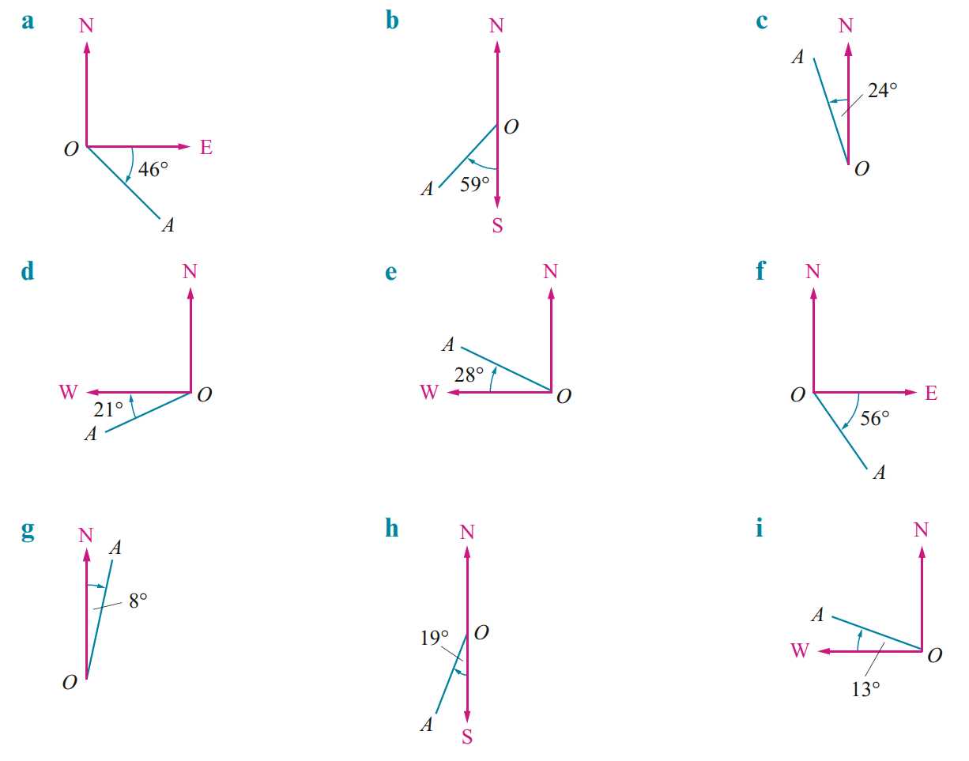  Compass:  S44°E  True:  136° | Compass:  S59°W  True:  239° | Compass:  N24°W  True:  336°
Compass:  S69°W  True:  249° | Compass:  N62°W  True:  298° | Compass:  S34°E  True:  146°
Compass:  N8°E  True:  008° | Compass:  S19°W  True:  199° | Compass:  N77°W  True:  283°

Calculating Bearing between Two Locations

- Bearing Between Two Locations
- “From” shows where you start a bearing.
- Bearing of “B from A” means: stand at A, find direction to B.
- In navigation, we use true bearing; compass bearings are rare.
- Bearings: https://www.geogebra.org/m/rpvgcshx
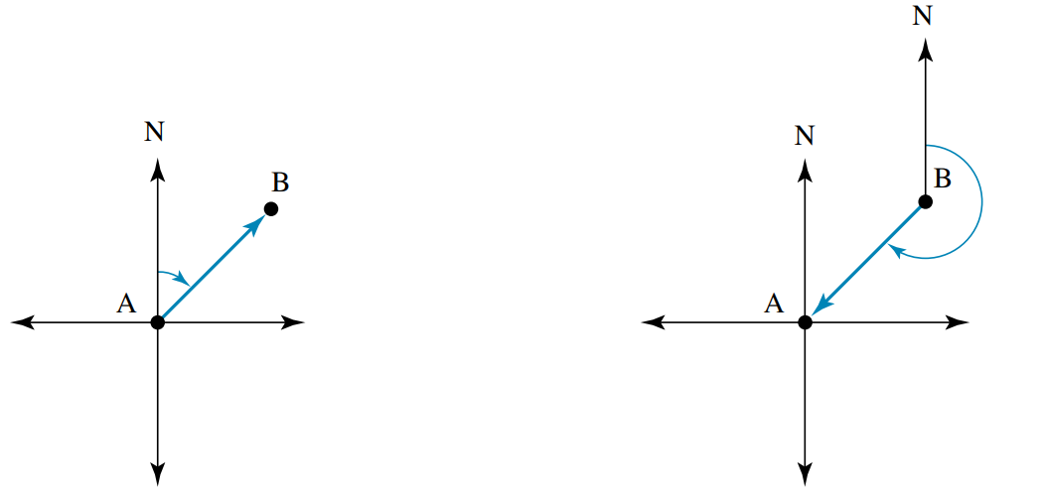  B from A | A from B
- Identify on your diagram the angle you are trying to find.
- Find the angle using angle relationships.

- Example Determine the bearing between two locations
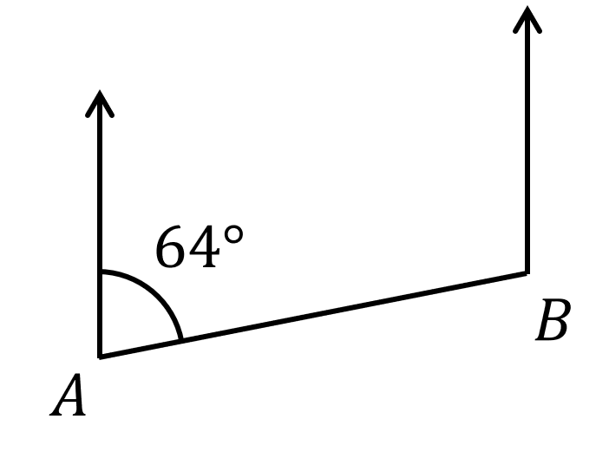
What is the bearing of $A$ from $B$?

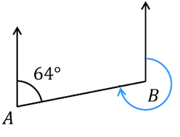  1. Identify angle | 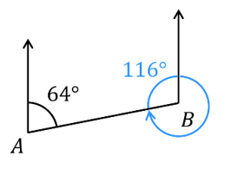  2.  Cointerior angles | 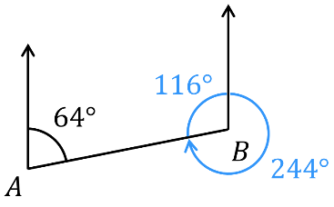  Angles at a point
The bearing of $A$ from $B$ is 244$°$

- Guided Practice
Determine the true bearing of
- $A$ from $B$  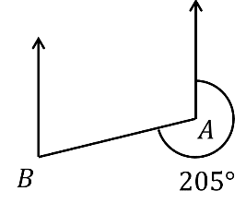  025° | - $A$ from $B$  255°
- $A$ from $B$  255° | - $A$ from $B$  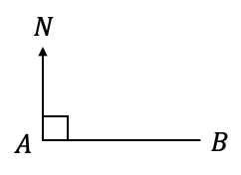  270°
- $O$ from $A$  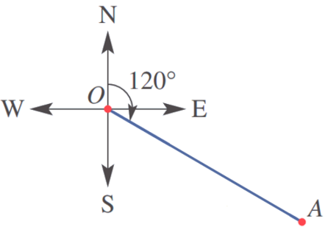  300° | - $O$ from $A$  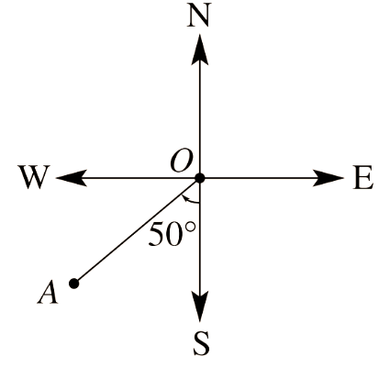  050°

Foundation

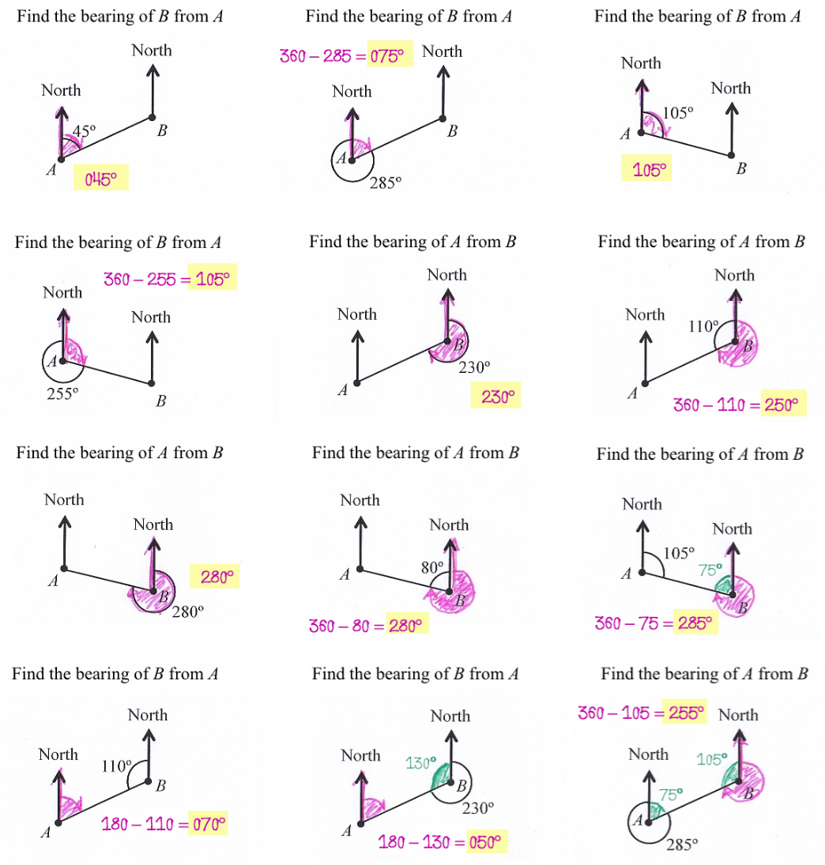
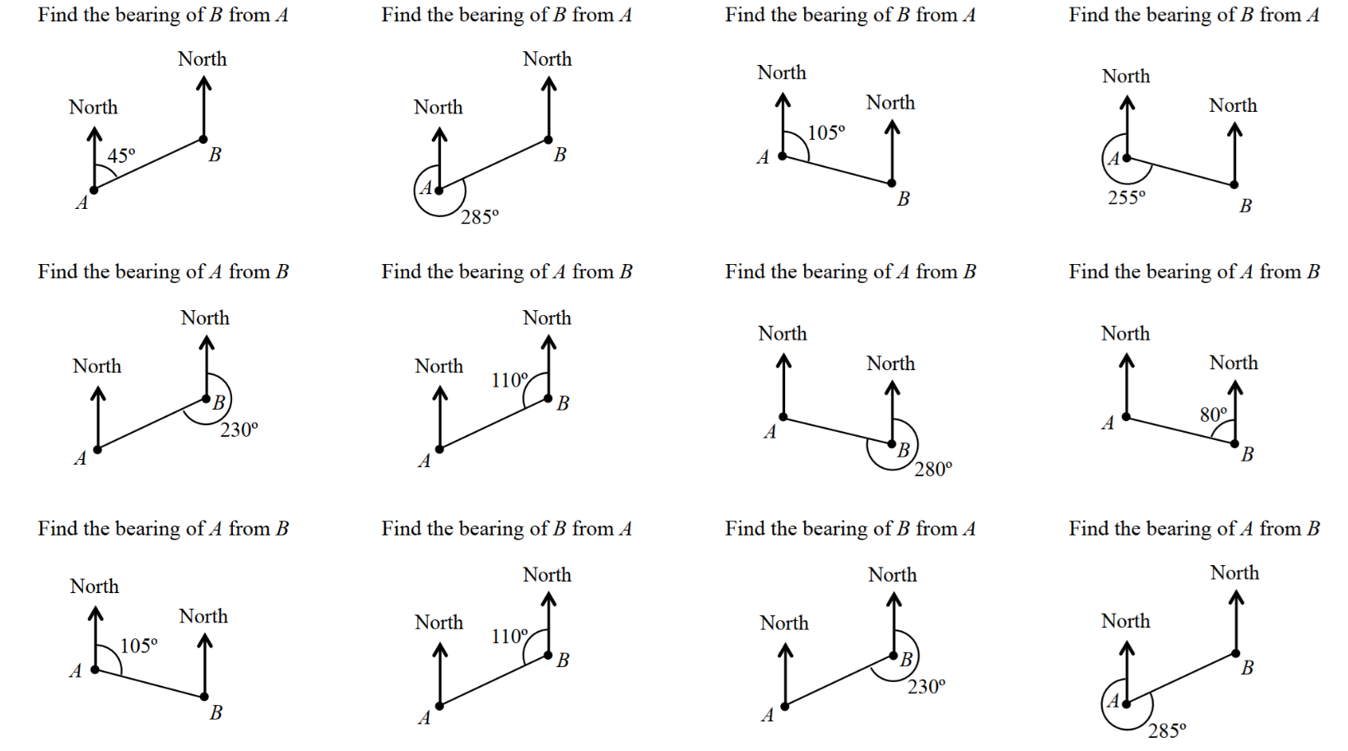

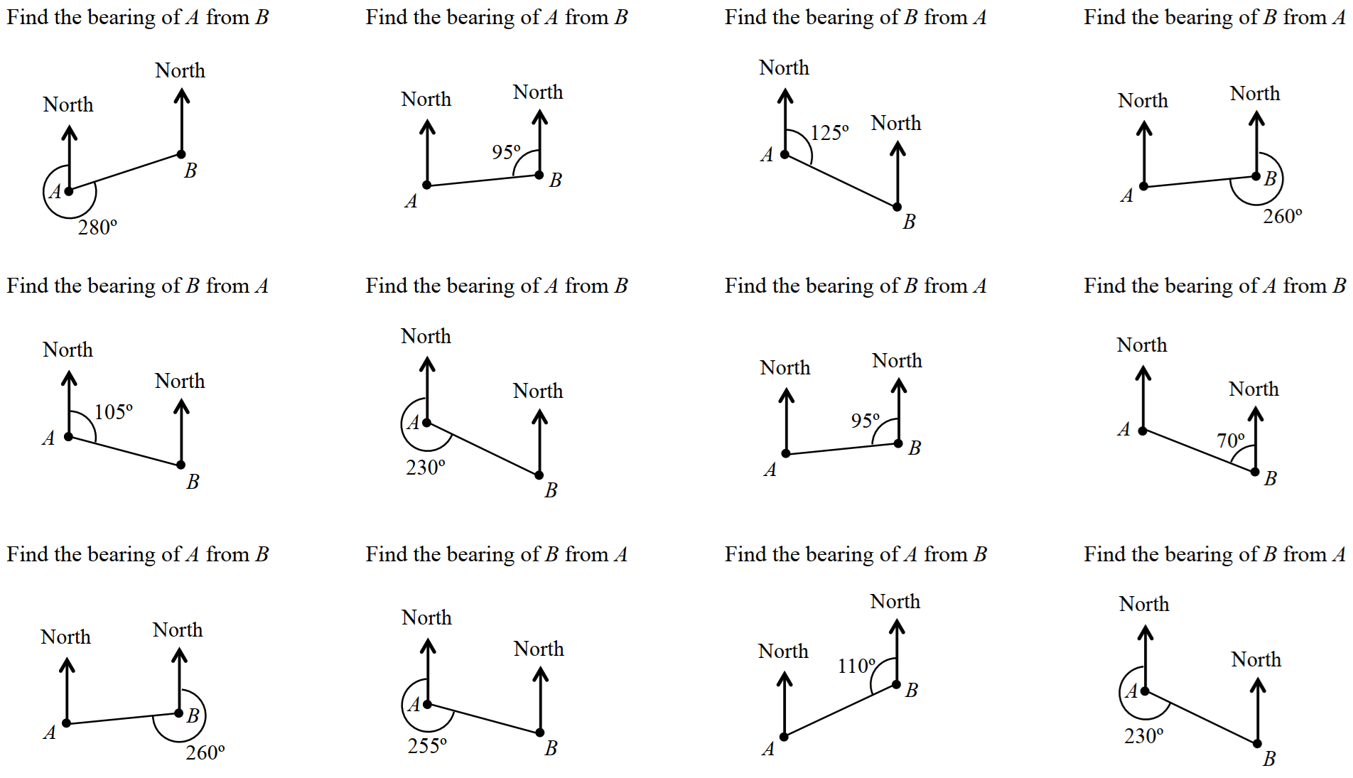 |  | 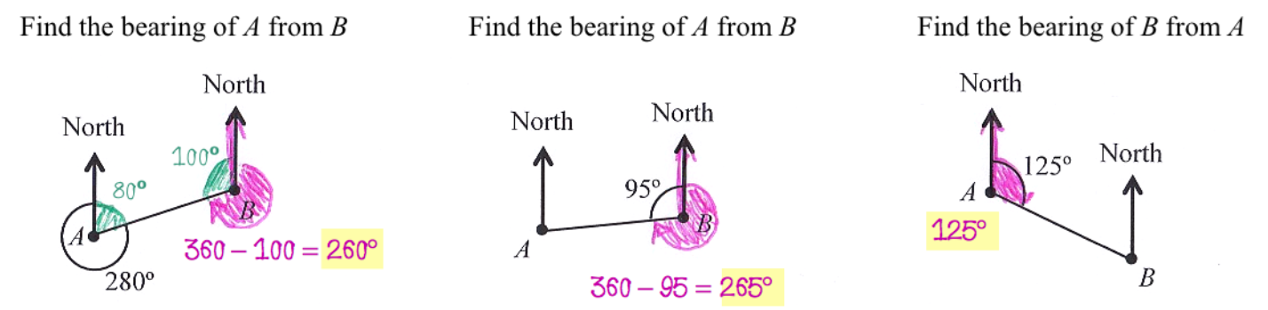
 |  | 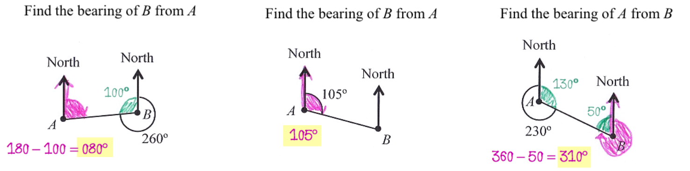
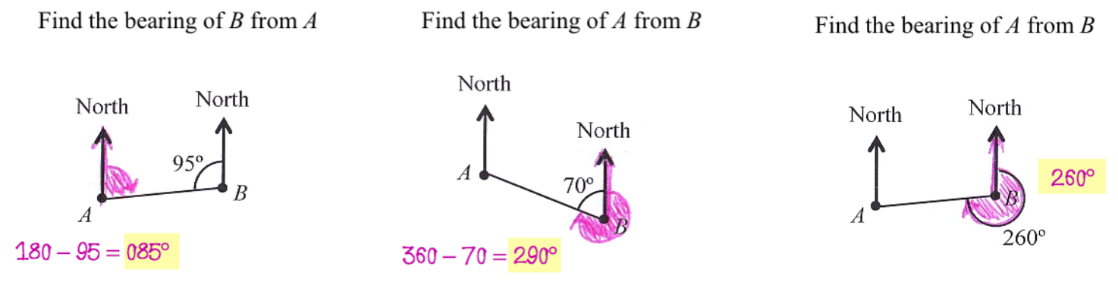

 | 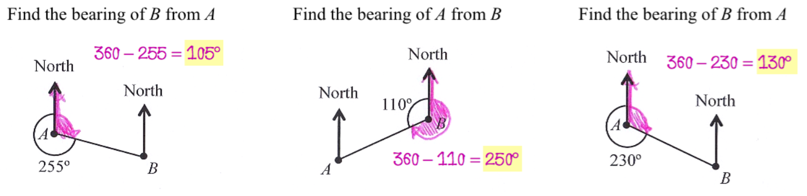

Development

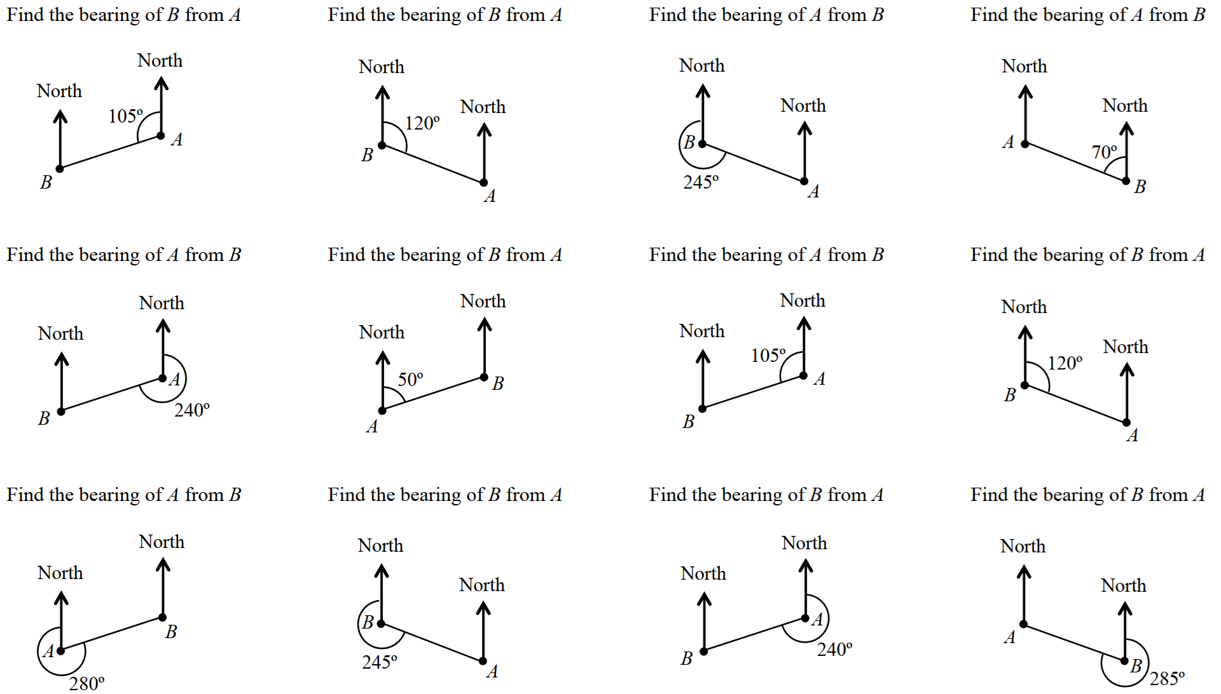 |  | 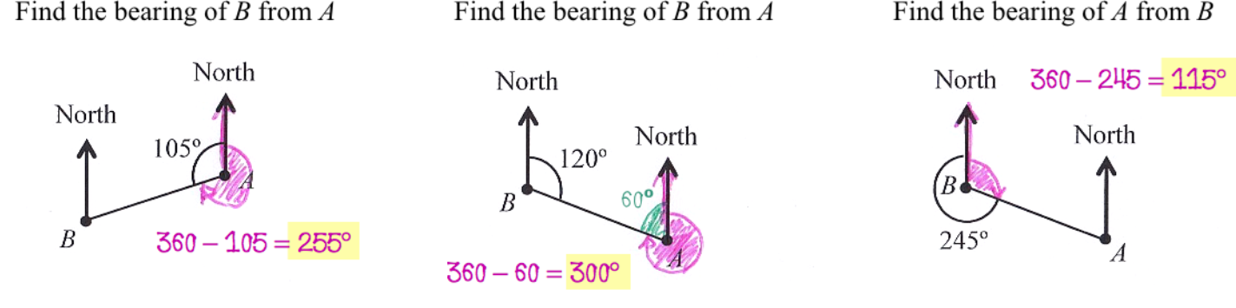
 |  | 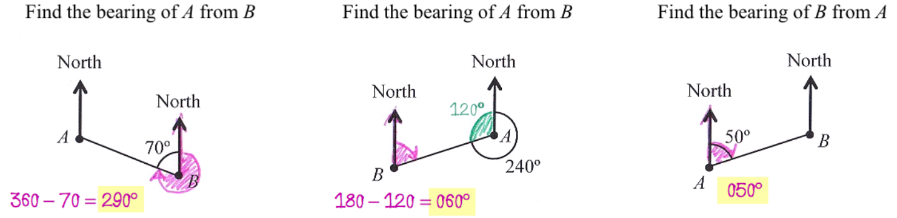
 |  | 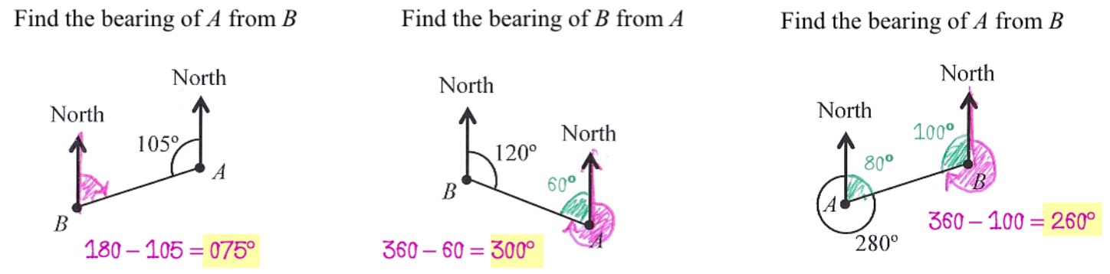
 | 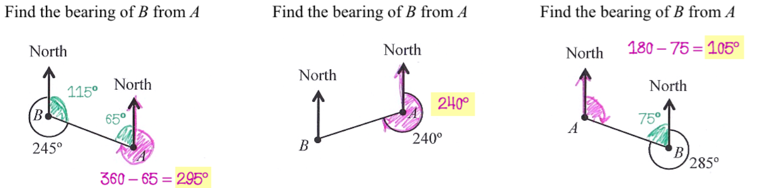

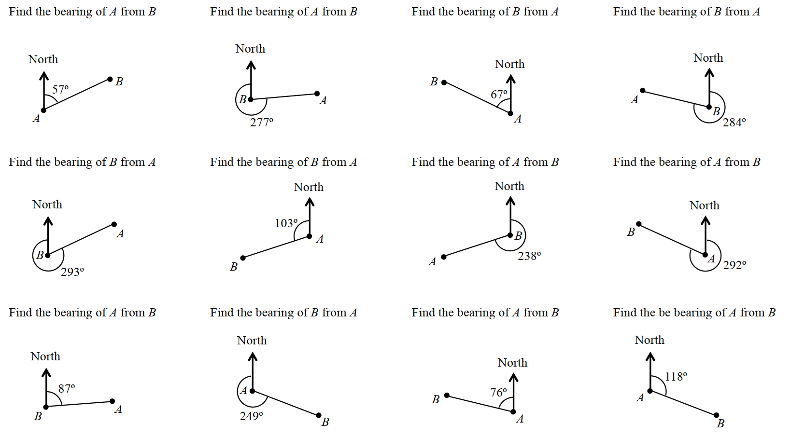 |  | 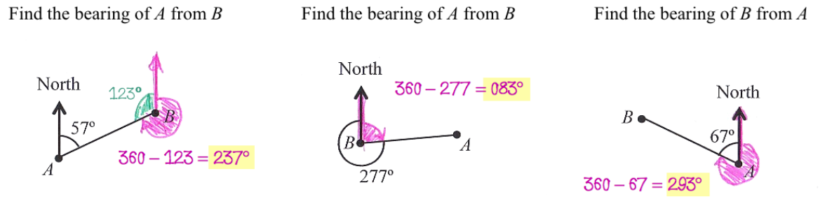
 |  | 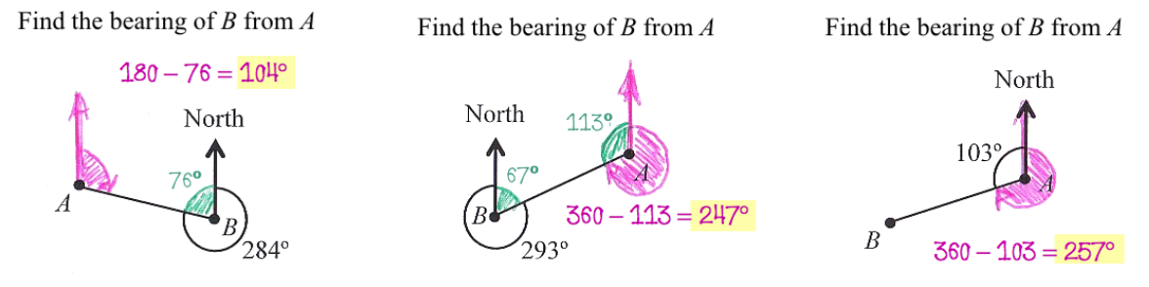
 |  | 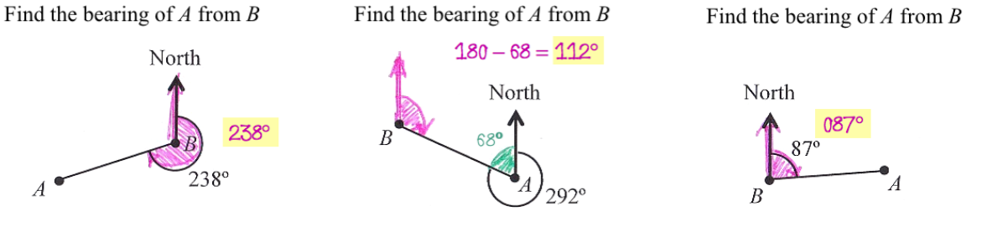
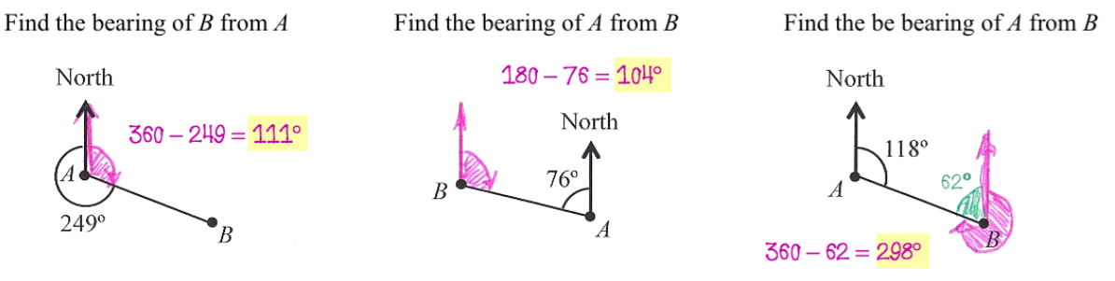

- Determine the bearing of $P$ from $Q$.
320° | 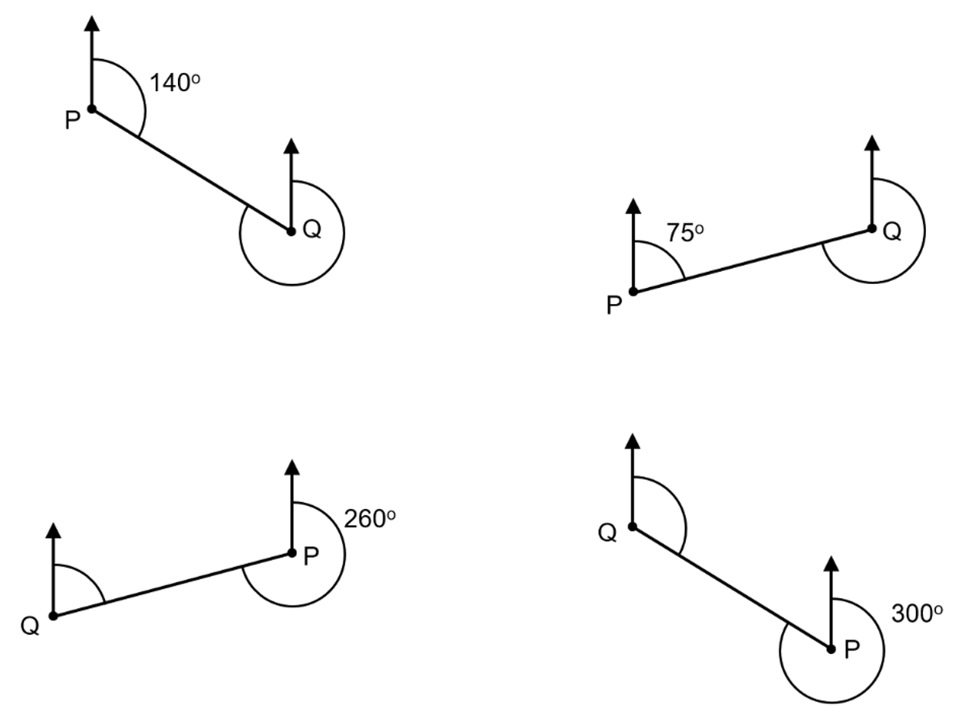  255°
080° | 120°

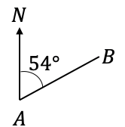
- Determine the bearing of $B$ from $A$.
054° | 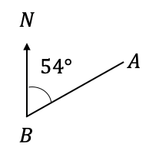  234° | 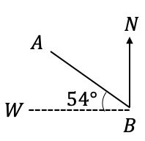  144° | 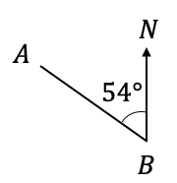  126°

- Determine the true bearing of $A$ from $B$.
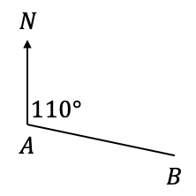  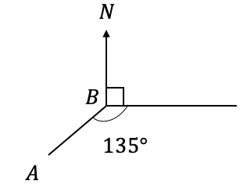  290° | 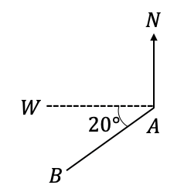  070°
225° | 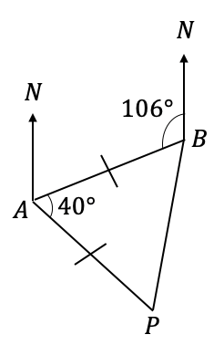  254°

- Given these bearings of $A$ from $O$, find the bearing of $O$ from $A$
- $123°$  $$O$$  303° | - $047°$  $$O$$  227°
- $231°$  $$O$$  051° | - $195°$  $$O$$  015
- $155°$  $$O$$  $$O$$  335° | - $343°$  163°

- 2021 HSC Standard 1
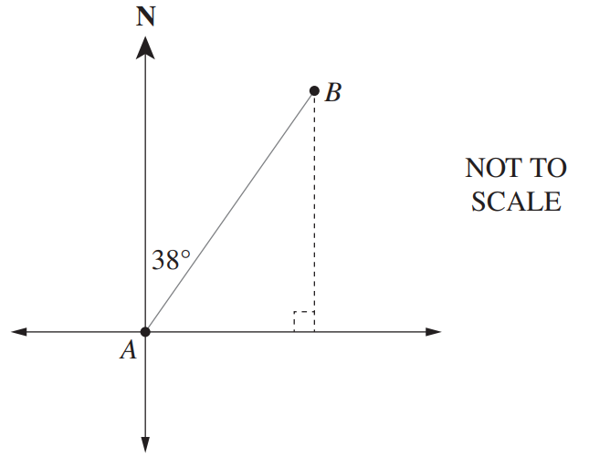
The compass bearing of B from A is N38°E. What is the true bearing of A from B?

218°
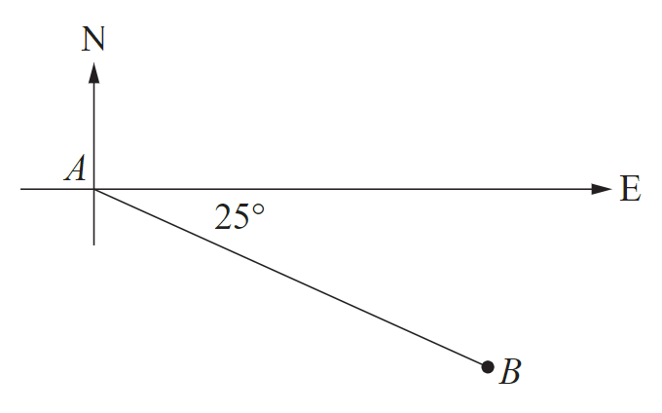
- 2021 HSC Standard 2 Band 5
What is the true bearing of A from B?

295°

Mastery

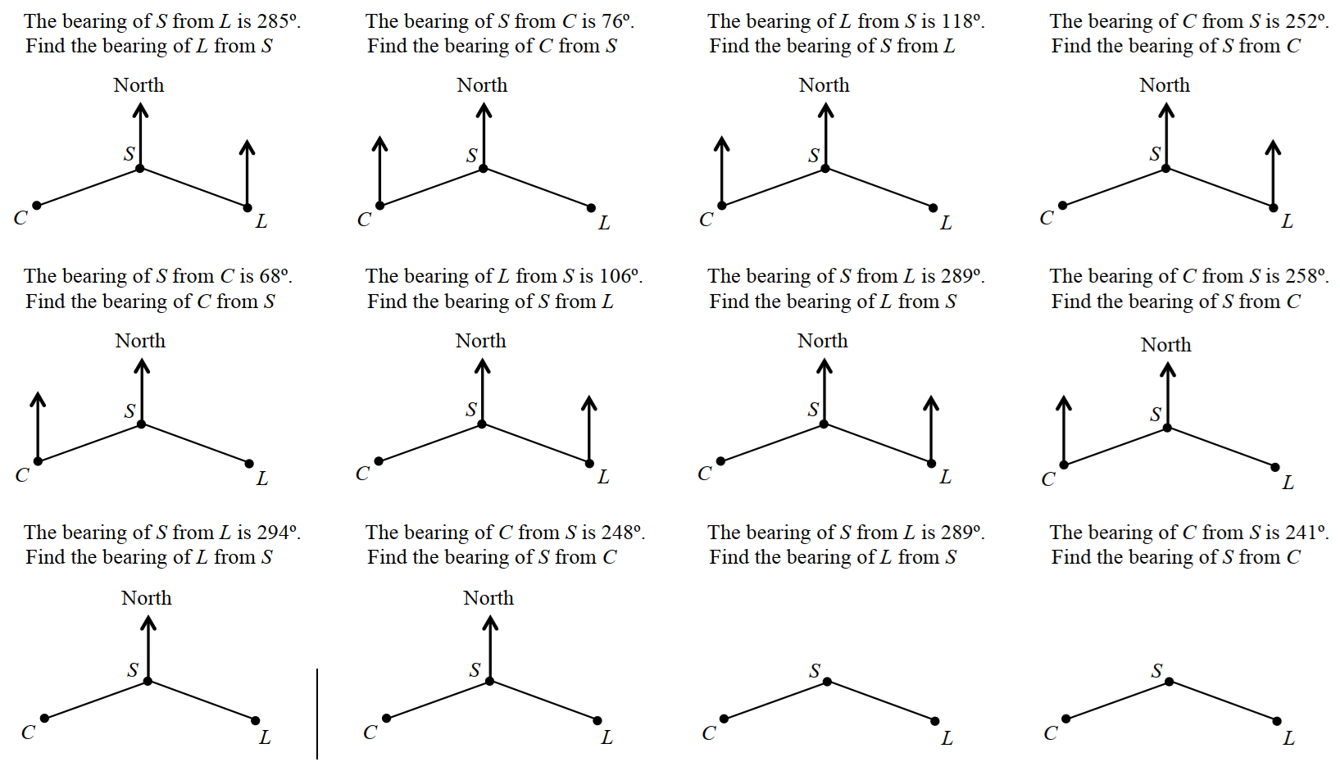 |  | 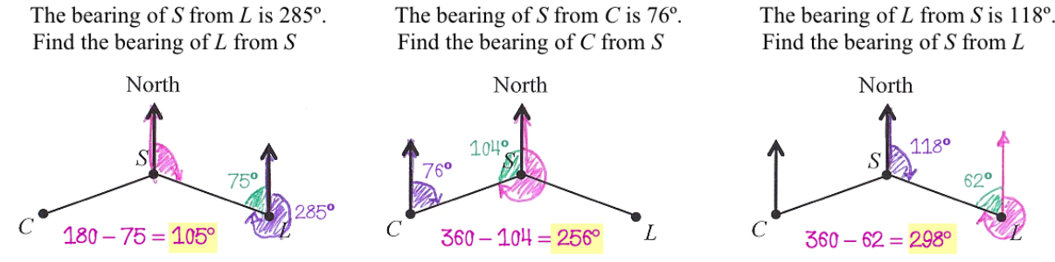
 |  | 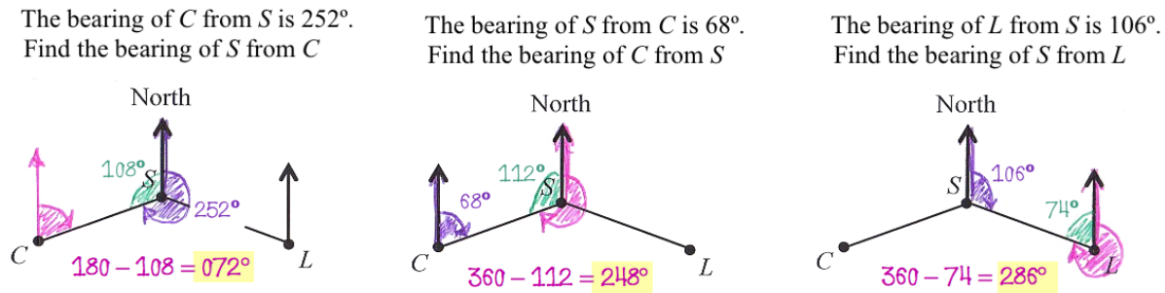
 | 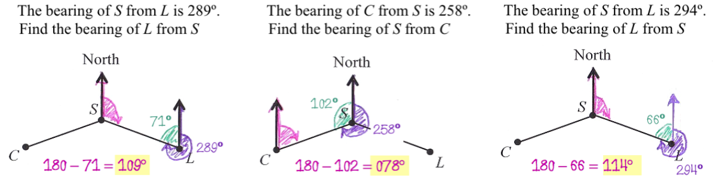
 |  | 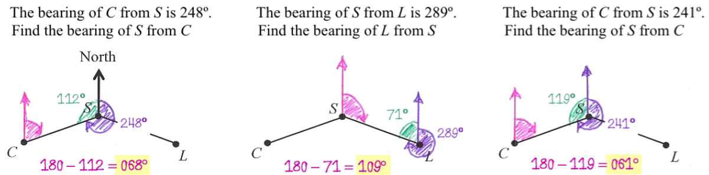

- 2022 HSC Standard 1
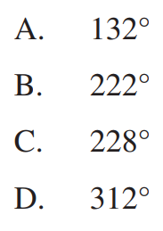
Which true bearing is the same as S48°W?

C

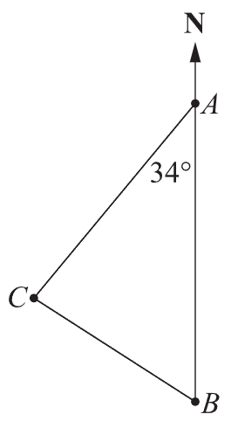
- 2018 HSC Standard 2 Band 4
The diagram shows the positions of towns A, B and C
What is the true bearing of Town C from Town A?

214°
- What is the bearing of:
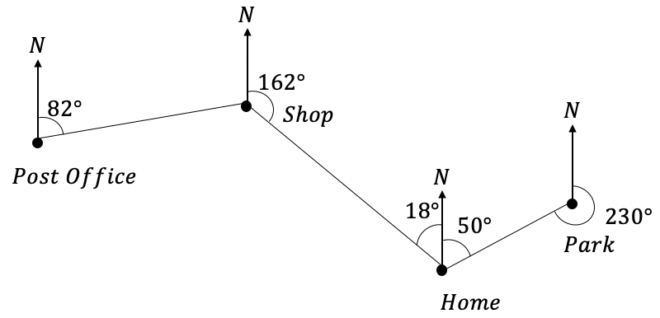
  - The shop from home?

342°
  - The post office from the shop?

262°
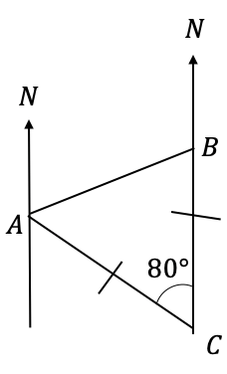
- What is the bearing of:
  - B from A?

050°
  - C from A?

100°
  - A from B?

230°
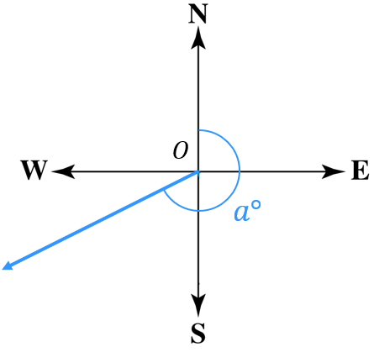
- A true bearing is $a$°. Write an expression for the true bearing of the opposite direction of $a$° if:
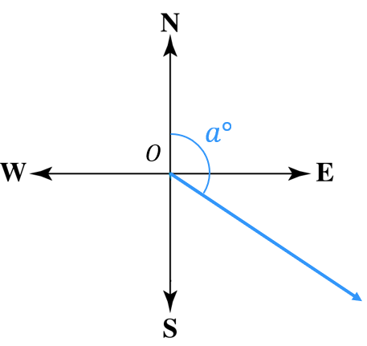  - $a$ is between 0$°$ and 180$°$  $$a+180$$ | - $a$ is between 180$°$ and 360$°$  $$a-180$$
- A hiker walks on a triangular pathway starting at point A, walking to point B then C, then A again.
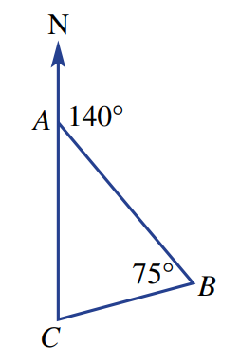
  - Find the bearing from B to A.

320°
  - Find the bearing from B to C.

245°
  - Find the bearing from C to B .

065°
- Find the bearing of $Q$ from $P$.
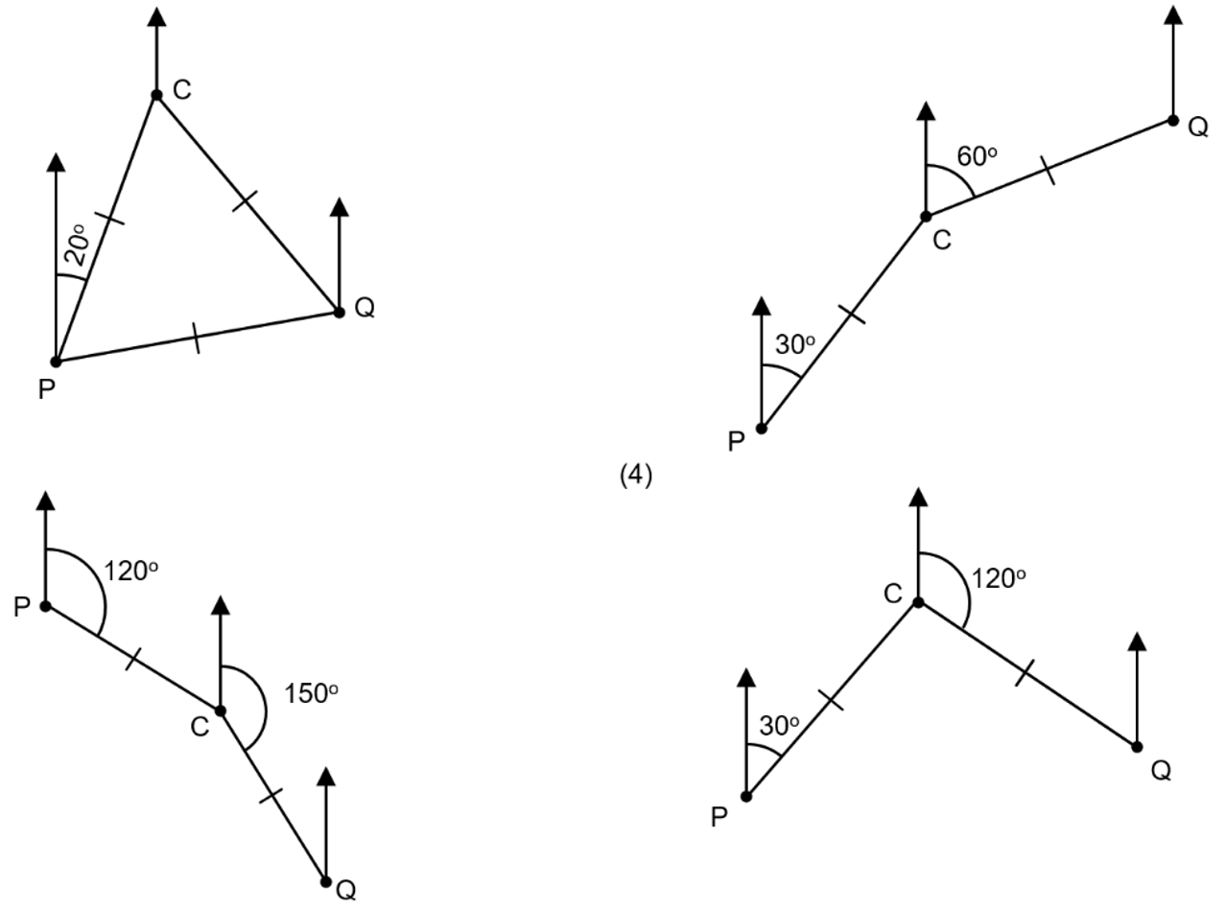  080° | 045°
135° | 075°

Interpreting Bearing Scenarios

Foundation
- Identify what bearing is shown in the diagram.
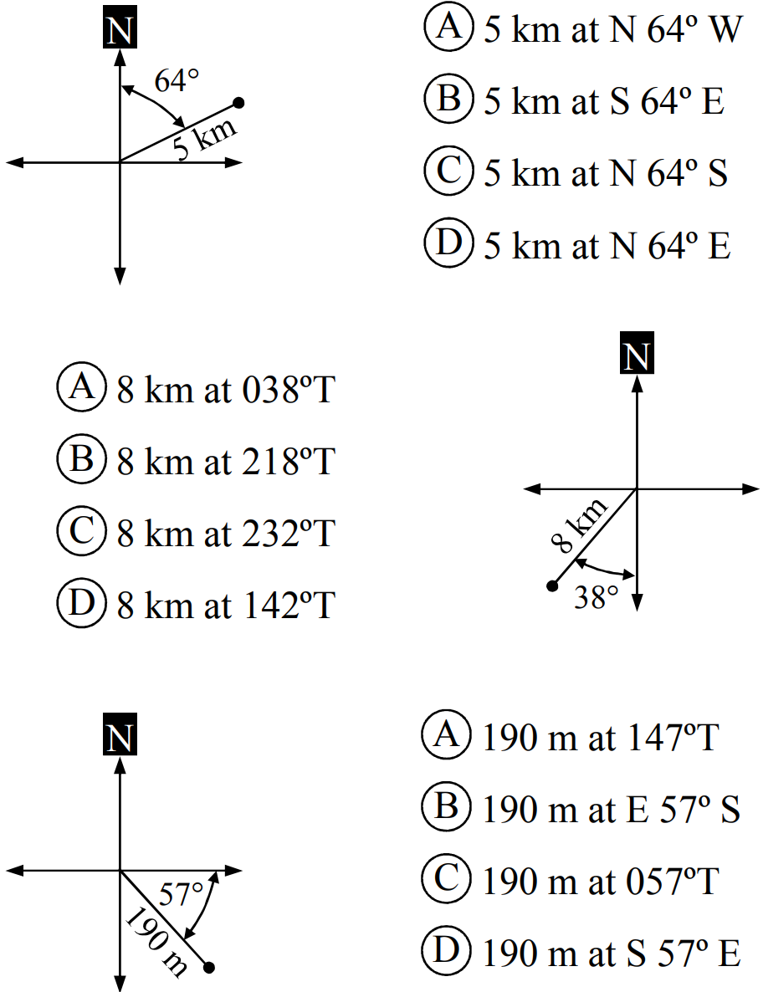  D | B | A | 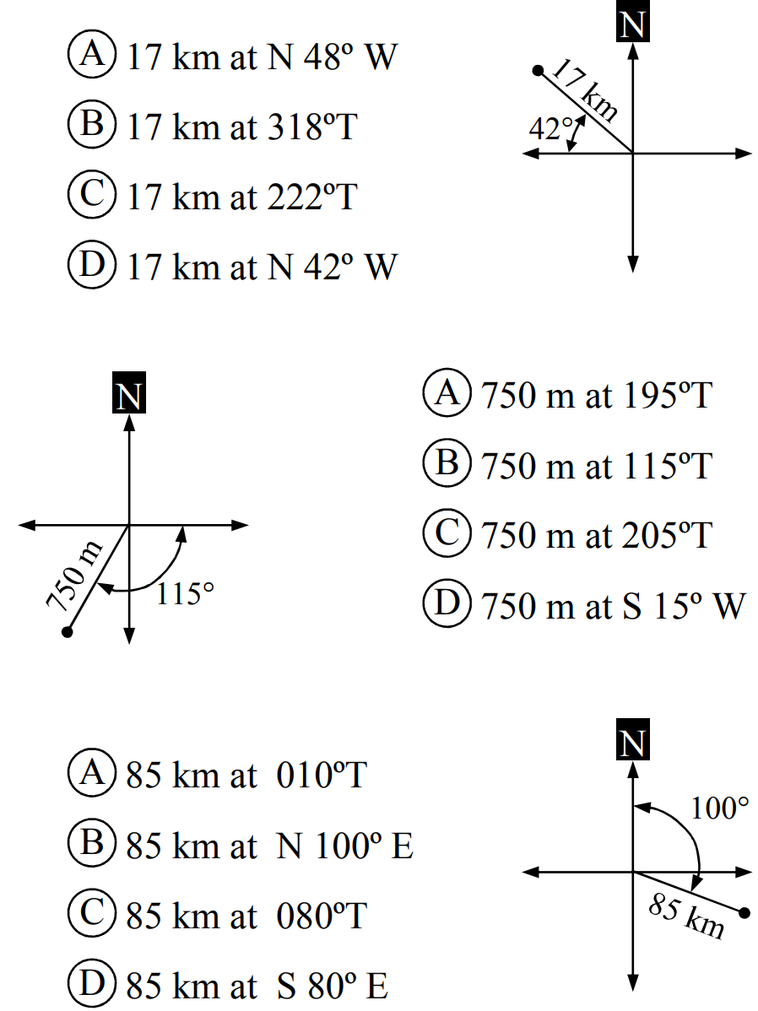  A
C | D | 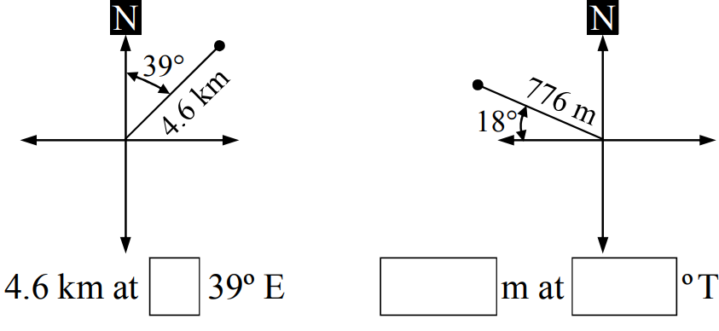  N | 776, 288
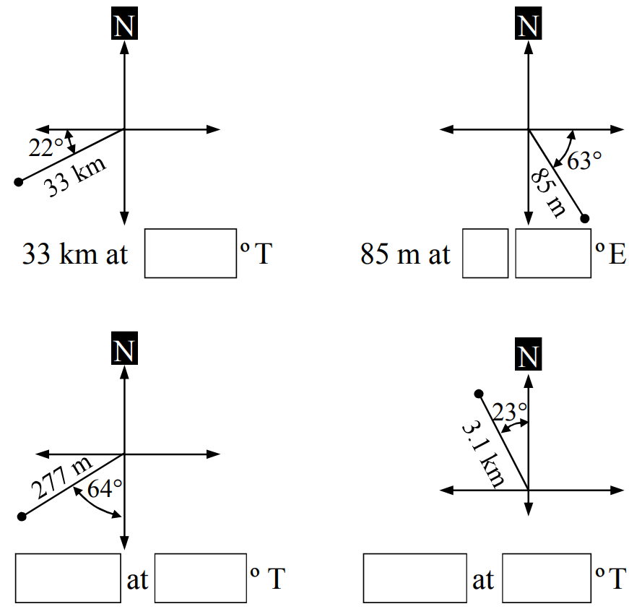  248 | S, 27 | 277 m, 244 | 3.1 km, 337

- Sketch the bearing and then label the distance and show the angle made with North or South.
- Toni walked 5 km at a bearing of 210ºT. | - Ben rode 15 km at a bearing of 320ºT  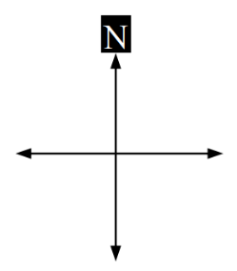  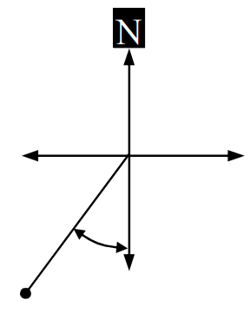 | - Roy drove 46 km at a bearing of 055ºT  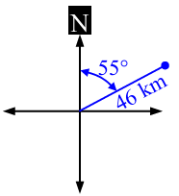  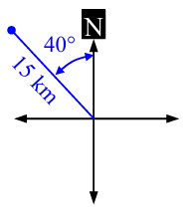  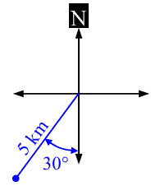
- Keira hiked 7 km at a bearing of S30ºW  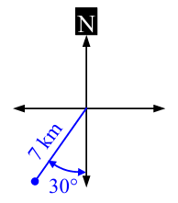 | - Mike sailed 25 km at a bearing of S45ºE  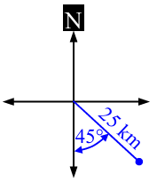 | - Duncan flew for 300 km at a bearing of N70ºW  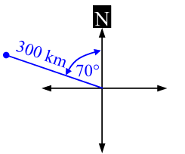

- Sketch the bearing, label the distance, show the angle made with North or South.
Then label the vertical ($y$) and horizontal ($x$) distance travelled.
The first question has been done for you.
- Jade trekked 19 km at a bearing of 210ºT.  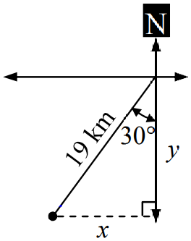 | - Ike walked 11 km at a bearing of 125ºT  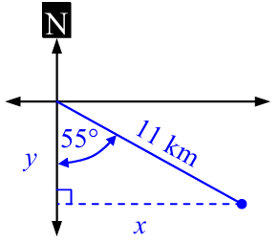  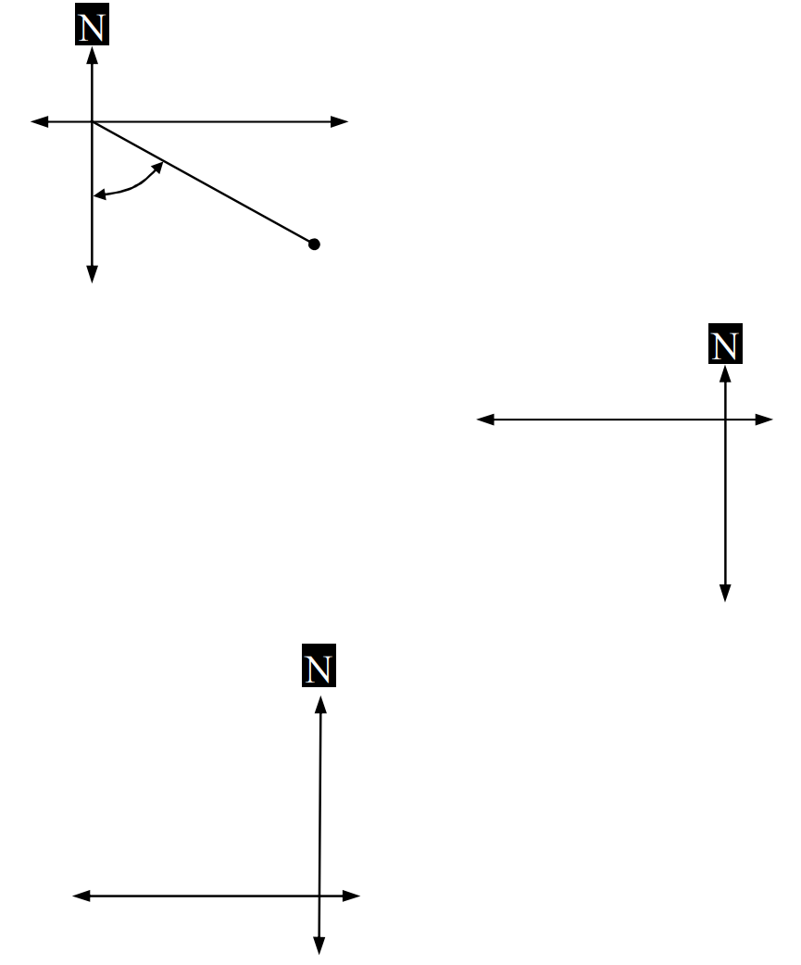 | - Nidal swam for 2.6 km at a bearing of 250ºT  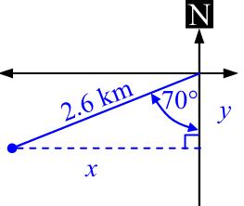
- Jiao trekked for 8 km at a bearing of N 25ºW.  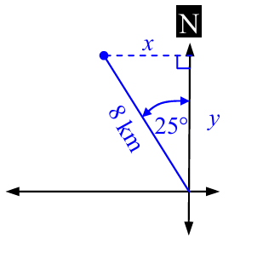 | - Blake rode for 11 km at a bearing of S 50º E.  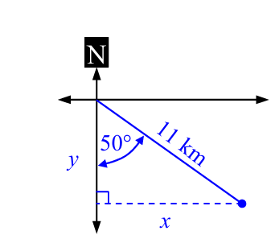 | - Allie sailed for 25 km at a bearing of N 35º E.  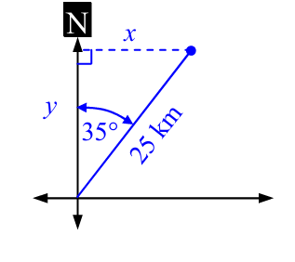

Problems Involving Bearings and Trigonometry

- Problems involving Bearings and Trigonometry
- Draw a diagram and a compass rose at each point.
Label all known information (known angles, distances, what you are trying to find).
- Draw an appropriate right-angled triangle.
- Find the unknown using trigonometry

- Example Solve problems involving bearings and trigonometry
A bushwalker walks 3 km on a bearing of 060$°$ from point A to point B.
Find how far east (correct to 1 decimal place) point B is from point A.
Step 1: Diagram  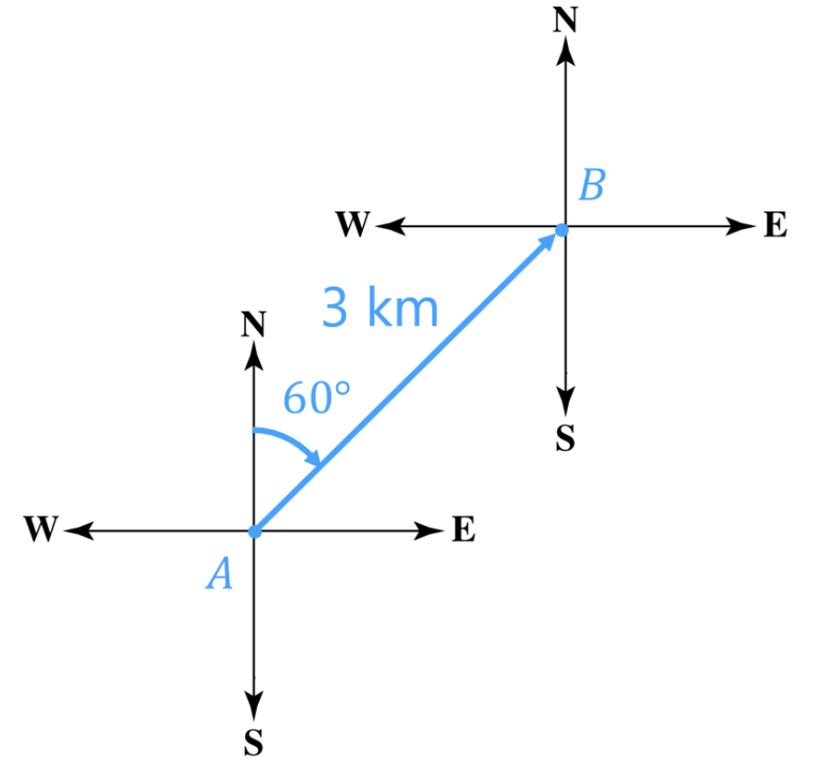 | 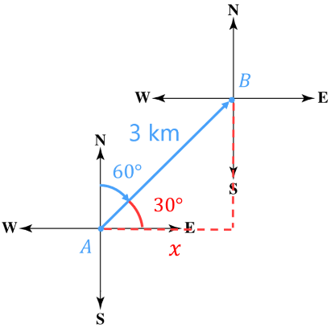  Step 2: Triangle | Step 3: Solve  $\cos\left(30°\right)=$ $\frac{x}{3}$  $3\cos\left(30°\right)=x$  $2.6 km=x$  The bushwalker is 3 km east of where they started.

- Guided Practice
- A fishing boat starts from point $O$ and sails 75 km on a bearing of 160° to point $B$.
How far east of its starting point is the boat, to the nearest kilometre?

26 km
- An athlete runs 10 km on a bearing of 200° from the start to the finish line.
How far south does the triathlete run? Answer to the nearest kilometre.

9 km

Foundation
- Label the sides O, A or H and calculate the unknown length to 1 decimal place.
- A ferry travels 32 km at a bearing of 242ºT.  Calculate how far West of its departure point ($x$) the ferry has travelled.  28.3 km | 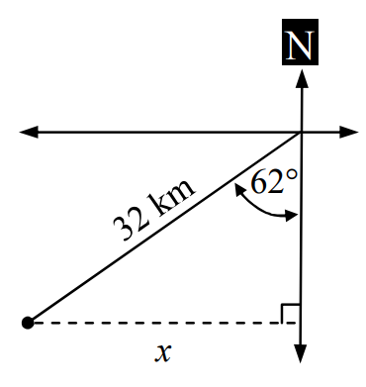  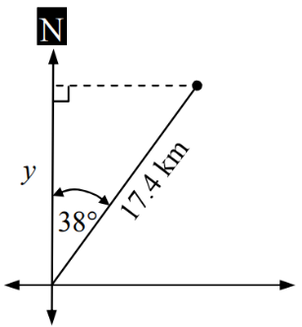  - Murali is trekking for 17.4 km at a bearing of N 38º E.  Calculate how far North of his starting point, ($y$), he has travelled.  13.7 km
- Briony is competing in a 6.7 km cross country run at a bearing of 115ºT. Calculate how far East ($x$) of her starting point she is when she finishes the run.  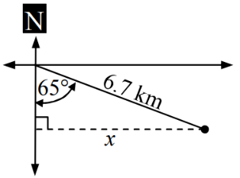  6.1 km | 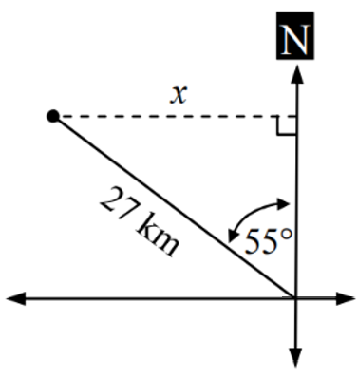  - Josh hiked for 27 km at a bearing of  N 55º W.  Calculate how far West of his original position he is at the end of the hike.  22.1 km
- Lucy sailed 33 km at a bearing of 142º T. Calculate how far South of her original position Lucy is.  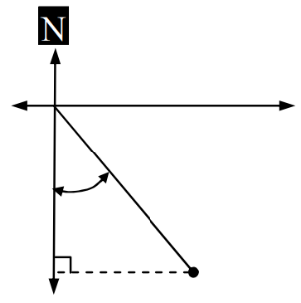  26 km | 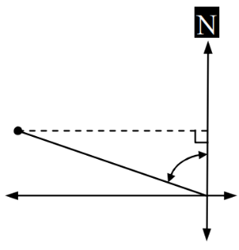  - Darius walked for 4.2 km at a bearing of 285ºT to a campsite.  How far North of his starting point is the campsite?  1.1 km

- Match the question to the diagram. Do not answer the questions.
- An orienteering course starts at A and  ends 4 km away at B on a bearing of 155º.  Find how far south B is from A. | 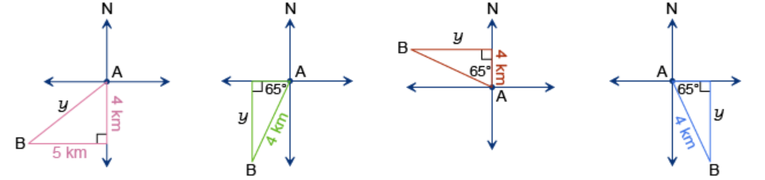  b
- A cyclist travelled south 4 km and then west for 5 km. Find the how far the cyclist was from her starting point. | d
- A fishing boat left harbour on a bearing 295º.  It anchored opposite a light house, 4 km north of the harbour. Calculate the distance from the ship to the lighthouse. | c
- A bushwalker set out on a bearing of 205º for 4 km. Find the distance she travelled south during her walk. | a

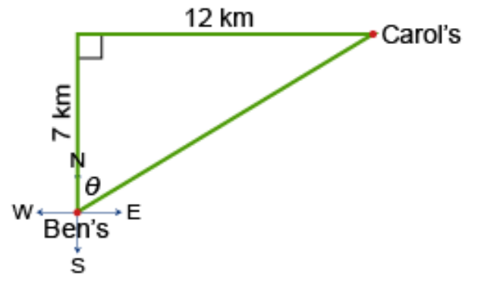
- Anne travelled 7 km due north from Ben’s house and then 12 km due east to Carol’s house. What is the true bearing from Ben’s house to Carol’s house? Answer to the nearest degree.

060$°$
- A rider travelled 4 km due east from A before changing direction and riding due north to B.
B is 6 km from A. Calculate the true bearing from A to B ($90-θ$). Answer to the nearest minute.
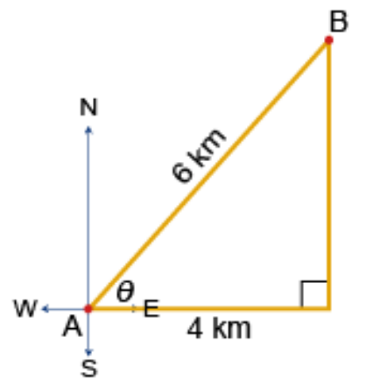

$$041°49'$$
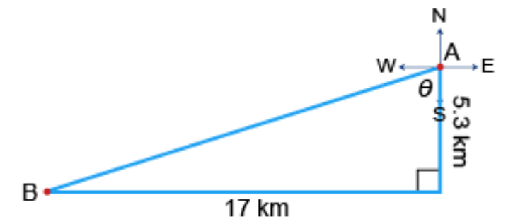
- A pigeon was released from A and flew 5.3 km due south before it turned west and continued to fly for another 17 km to reach B. Calculate the true bearing $\left(180+θ\right)$ of the pigeon at B from A.

$$252°41'$$
- A plane departed Sydney and flew due south for 350 km.
It then turned and flew due east for 500 km before landing on an island.
Calculate the bearing from the island to Sydney to nearest degree.
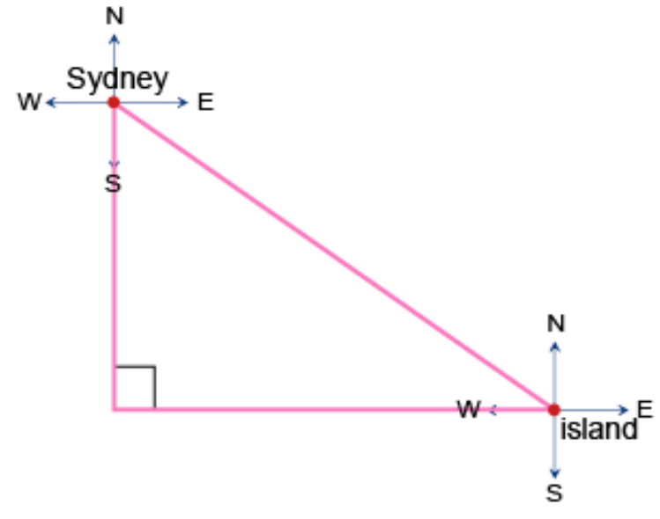

305$°$
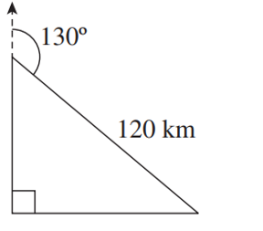
- Eleni drives 120 km on a bearing of $130°$.
She then drives due west until she is directly south of her starting point.
How far is she from her starting point, correct to the nearest kilometre?

77 km

Development
- A bushwalker walks 4 km on a bearing of 055° from point A to point B.
Find how far east point B is from point A, correct to 2 decimal places.
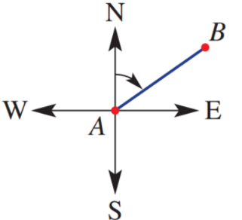

3.28 km
- A speed boat travels 80 km on a bearing of 048°.
Find how far east of its starting point the speed boat is, correct to 2 decimal places.
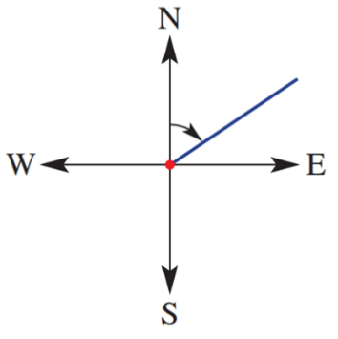

59.45 km
- A fishing boat starts from point $O$ and sails 60 km on a bearing of 140° to point $B$.
  - How far east of its starting point is the boat, to the nearest kilometre?
  - What is the bearing of O from B?
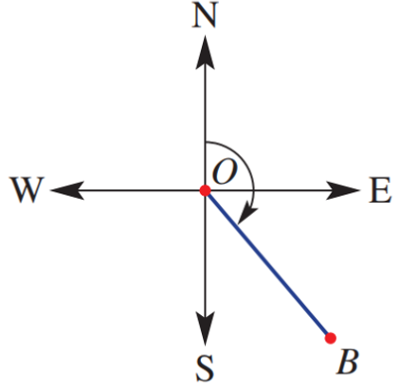

39 km, 320° T
- Two towns, A and B, are 12 km apart. The bearing of B from A is 250°
  - How far west of A is B, correct to 1 decimal place?
  - Find the bearing of A from B
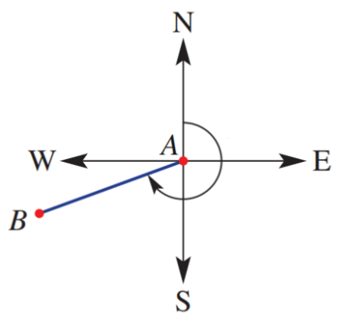

11.3 km, 070° T
- Two points, A and B, positioned 15 cm apart, are such that B is 100° from A.
  - Find how far east point B is from A, correct to 2 decimal places.
  - Find how far south point B is from A, correct to the nearest millimetre.

14.77 cm, 2.6 cm
- A helicopter flies on a bearing of 140° for 210 km then flies due east for 175 km.
How far east (to the nearest kilometre) has the helicopter travelled from its starting point?

310 km
- A tank moves 13.5 km from point A on a bearing of 042° to point B.
From point B, how far due south must the tank travel to be at a point due east of point A?
Give the answer correct to the nearest metre.

10.032 km

Mastery
- The bearings of towns $Y$ and $Z$ from town $X$ are 060°T and 330°T respectively.
  - Show that $∠ZXY=90°$.
  - Given that town $Z$ is 80 km from town $X$ and that $∠XYZ=50°$,
find correct to the nearest kilometre, the distance between town $Y$ and town $X$.

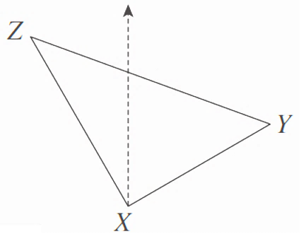

67 km
- Port Q is 45 nautical miles from port P on a bearing of 055°T.
Port R is 65 nautical miles from port P, and ∠PQR = 90°.
  - Find $∠QPR$ to the nearest degree.
  - Hence find the bearing of $R$ from $P$ to the nearest degree.
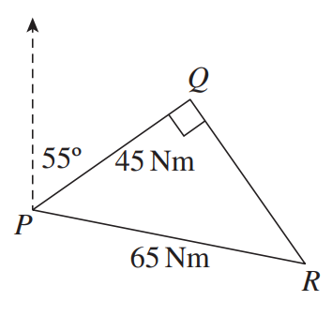

$$∠PQR=46°$$
$$101°$$
- A ship leaves port P and travels 150 nautical miles to port Q on a bearing of 110°T.
It then travels 120 nautical miles to port R on a bearing of 200°T.
  - Explain why $∠PQR=90°$
  - Find the bearing of $R$ from $P$ to the nearest degree.
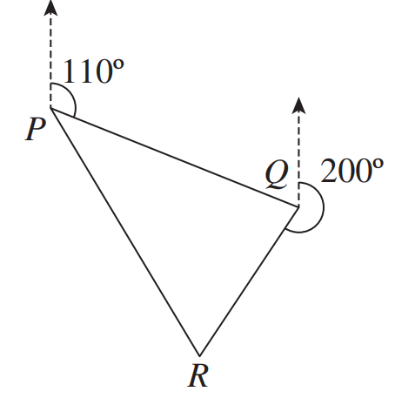

∠PQR = 360° − (200° + 70°) = 90°
(using co-interior angles on parallel lines and the fact that a revolution is 360°)
110° + 39° = 149°
- A helicopter flew from a town on a bearing of 315º and travelled for 40 km to pick up its cargo from a depot. The helicopter then carried the cargo to a construction site on a bearing of 225º. The construction site is 105 km from the town.
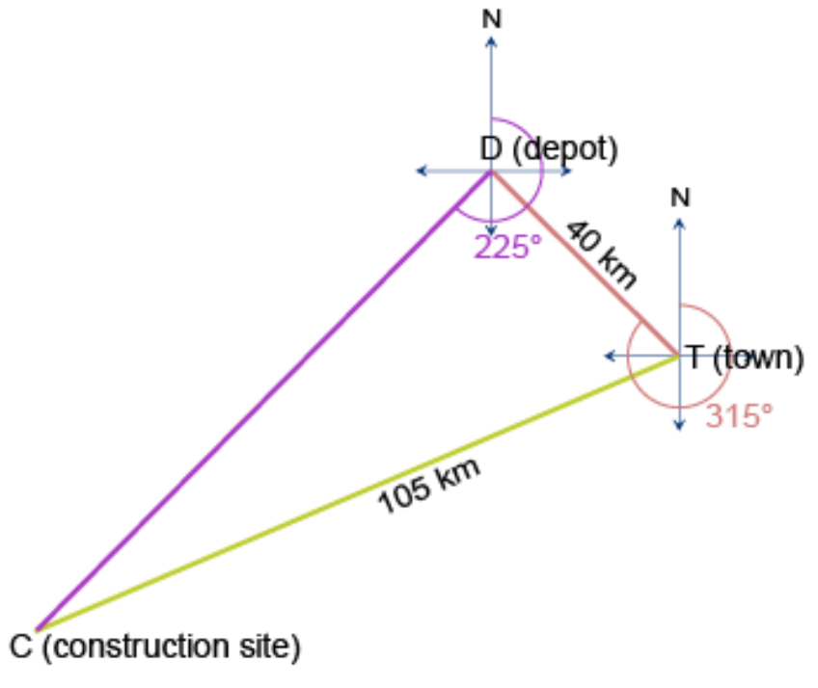
  - Show that $Δ$TDC is a right-angled triangle.

Bearing of D from T is 315, so the bearing of T from D is 135$°$
$$225°-135°=90°$$
$∴∠CDT=90°$ so $ΔTDC$is right-angled.
  - Calculate the bearing of the construction site from
the town, to the nearest minute.

$$\cos{∠DTC}=\frac{40}{105},$$
$$∴∠DTC=36°36'$$
$∴$ bearing = $315-36°{36}^{'}=247°24'$
- 2 ships leave from the same port. One ship travels on a bearing of $157°$ at 20 knots.
The second ship travels on a bearing of $247°$ at 35 knots.
(A knot is a speed of 1 nautical mile per hour).
  - How far apart at the ships after 8 hours? Answer in nautical miles to 2 d.p.
  - Calculate the bearing of the second ship from the first, to the nearest minute.

322.49 nautical miles, 276° 45ʹ
- A plane flies 1200 km on a NE compass bearing and then changes direction to a bearing of NW and flies for 450 km.
  - How far, correct to the nearest km, is the plane from its starting point?
  - What is the bearing of the plane from its starting point, to the nearest metre?

1282 km, 024° 27ʹ
- HSC Standard 2 Sample Question Band 4
Checkpoint C is due east of Checkpoint A.
The bearing of Checkpoint B from Checkpoint A is N22°E
and the bearing of Checkpoint C from Checkpoint B is S68°E.
The distance between Checkpoint A and Checkpoint B is 42 kilometres.
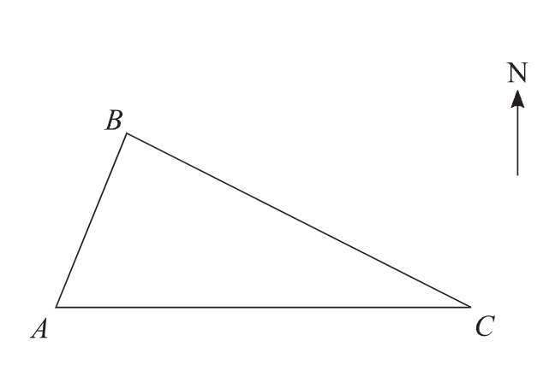
  - Label the diagram and explain why $∠ABC=90°$

  - Find the distance, to the nearest kilometre, between Checkpoint A and Checkpoint C

112 km
  - If a runner is travelling 12.6 km/h, how long does it take
her to travel between Checkpoint A and Checkpoint B, in hours and minutes?

3 h 20 m
- A rally driver heads in a direction of 145° at a speed of 120 km/ h for 3 hours.
The rally driver then turns and drives north until he is due east of the starting point.
How long will this take at 120 km/ h? Answer to the nearest minute.

The rally driver travels 360 km at a bearing of 145$°$
This is $360\cos{35°}$ km south of his starting position.
$360\cos{35°}km÷120 km/h=2.4574…$ hours
2 hours 27 minutes

